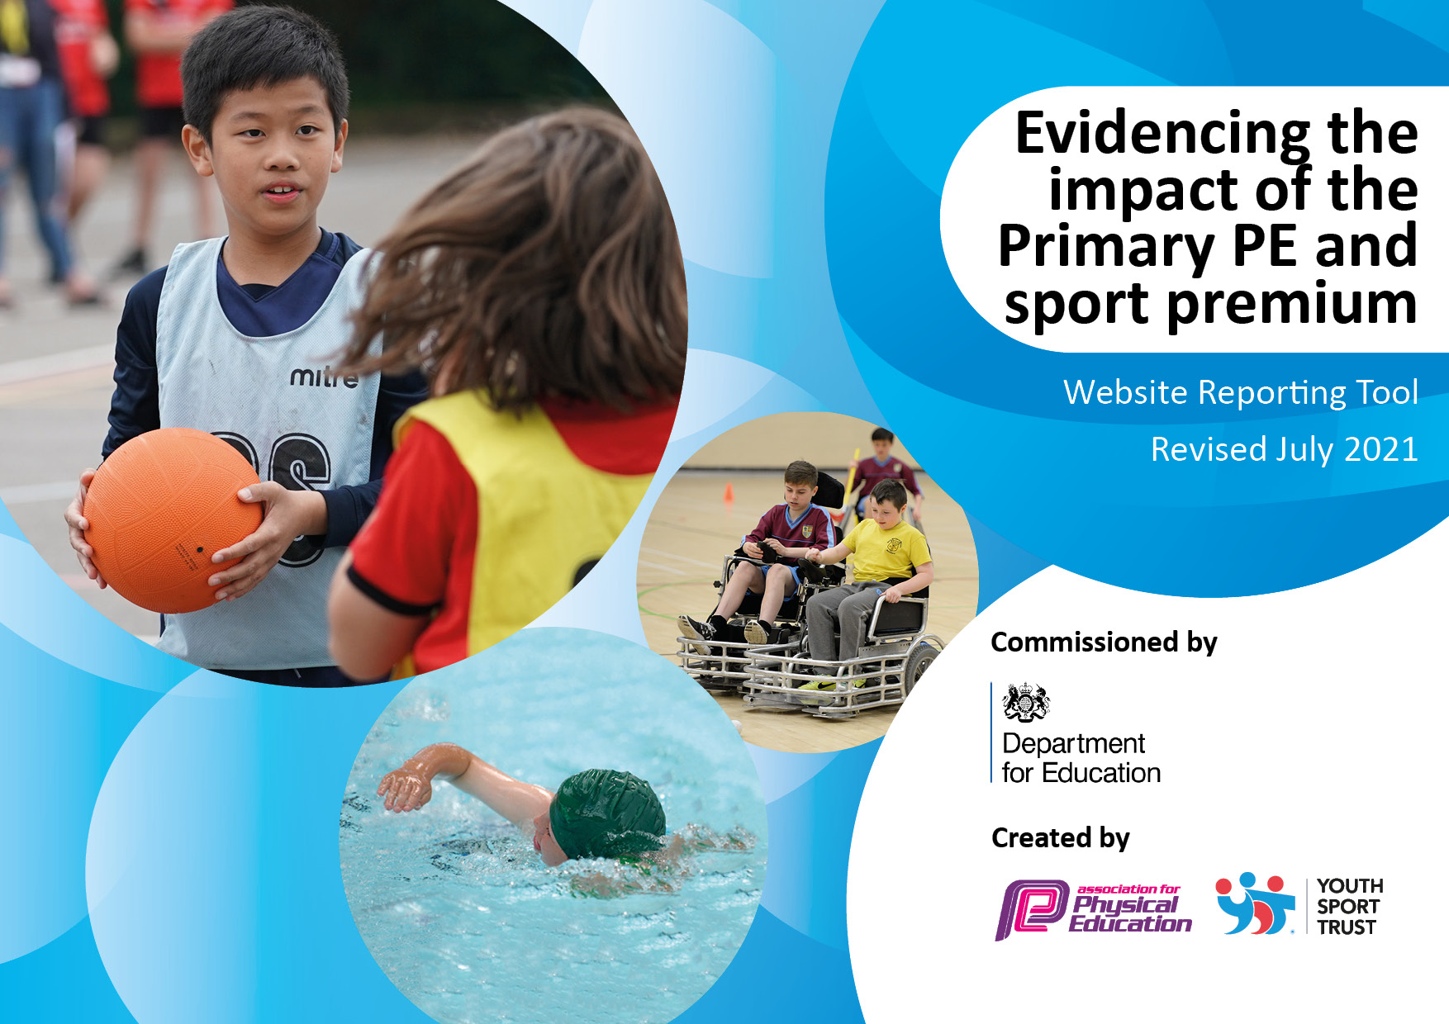
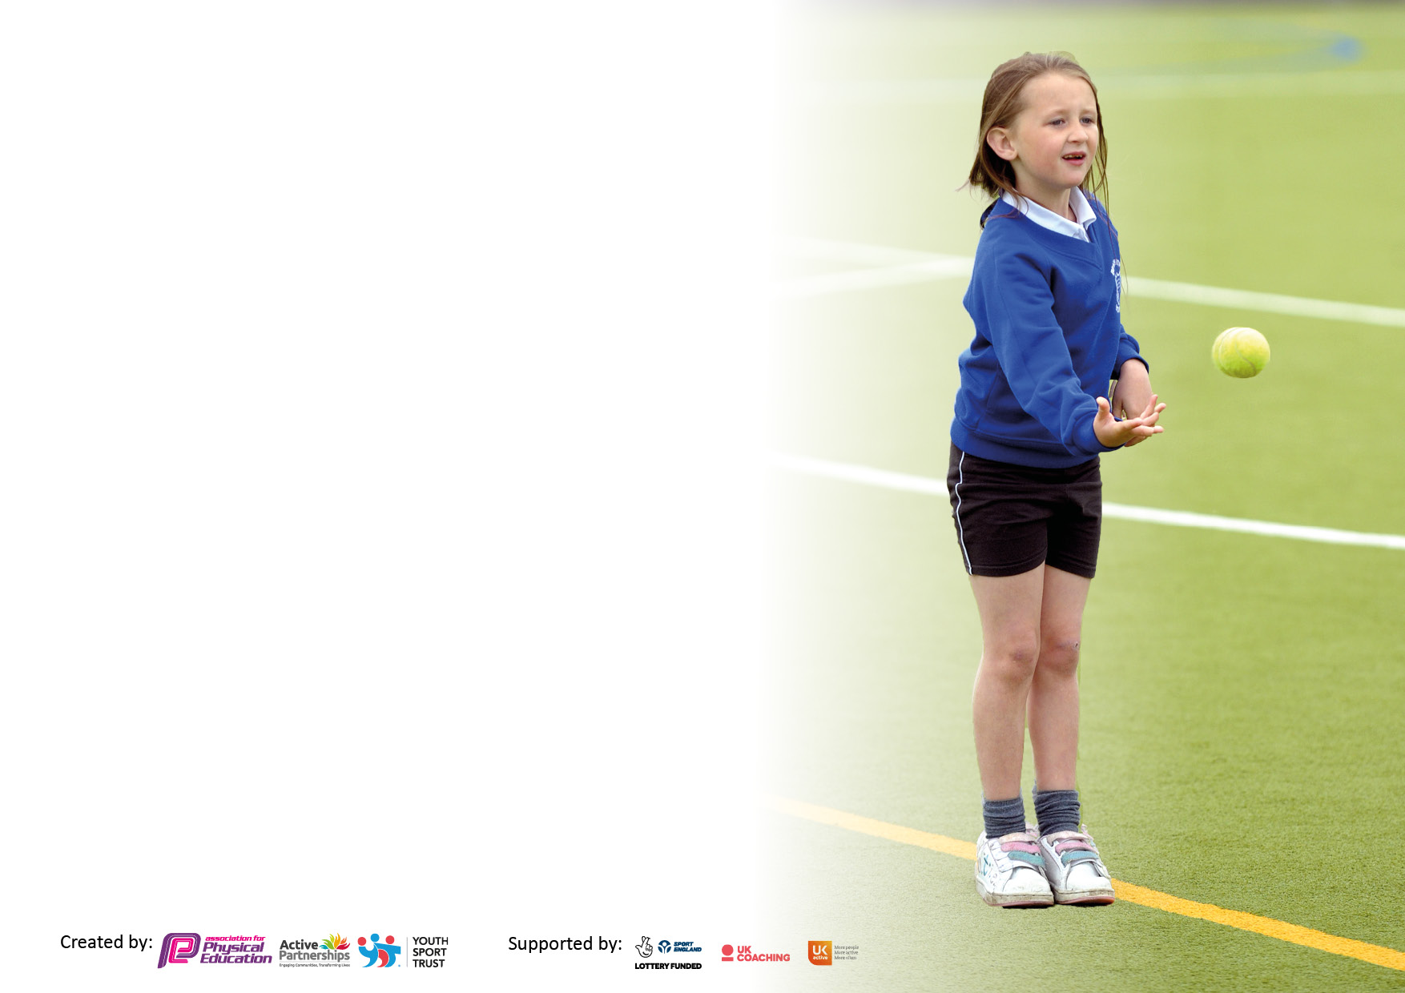

It is important that your grant is used effectively and based on school need. The Education Inspection Framework makes clear there will be a focus on ‘whether leaders and those responsible for governors all understand their respective roles and perform these in a way that enhances the effectiveness of the school’.

Under the Quality of Education Ofsted inspectors consider:
Intent - Curriculum design, coverage and appropriateness
Implementation - Curriculum delivery, Teaching (pedagogy) and Assessment
Impact - Attainment and progress

To assist schools with common transferable language this template has been developed to utilise the same three headings which should make your plans easily transferable between working documents.

Schools must use the funding to make additional and sustainable improvements to the quality of Physical Education, School Sport and Physical Activity (PESSPA) they offer. This means that you should use the Primary PE and sport premium to:

- Develop or add to the PESSPA activities that your school already offer
- Build capacity and capability within the school to ensure that improvements made now will benefit pupils joining the school in future years
- The Primary PE and sport premium should not be used to fund capital spend projects; the school’s budget should fund these.

Please visit gov.uk for the revised DfE guidance including the 5 key indicators across which schools should
Demonstrate an improvement. This document will help you to Review your provision and to report your spend. DfE encourages schools to use this template as an effective way of meeting the reporting requirements of the Primary PE and sport premium.

We recommend you start by reflecting on the impact of current provision and reviewing the previous spend.

Schools are required to publish details of how they spend this funding, including any under-spend from 2019/2020, as well as on the impact it has on pupils’ PE and sport participation and attainment. All funding must be spent by 31st July 2022.

We recommend regularly updating the table and publishing it on your website throughout the year. This evidences your ongoing self-evaluation of how you are using the funding to secure maximum, sustainable impact. Final copy must be posted on your website by the end of the academic year and no later than the 31st July 2021. To see an example of how to complete the table please click HERE.

Details with regard to funding
Please complete the table below.

At the time of writing (July 21) the school has been through periods of lockdown due to the coronavirus pandemic. We have been working within
Government guidelines. This has impacted on our P.E offer and reduced what we have been able to offer. For example, the school has not been able to run
swimming sessions or after school clubs as we would in normal circumstances. The school is committed to active healthy pupils as we appreciate that the
best way to fight the virus is to promote healthy active lifestyles but we will put pupil and staff safety first.

Total amount carried over from 2019/20 | £2,500
Total amount allocated for 2020/21 | £22,500
How much (if any) do you intend to carry over from this total fund into 2021/22? | £0
Total amount allocated for 2021/22 | £20,220
Total amount of funding for 2021/22. To be spent and reported on by 31st July 2022. | £20,220
Swimming Data
Please report on your Swimming Data below.

Meeting national curriculum requirements for swimming and water safety.

N.B. Complete this section to your best ability. For example you might have practised safe self-rescue techniques on dry land which you can then transfer to the pool when school swimming restarts.
Due to exceptional circumstances priority should be given to ensuring that pupils can perform safe self rescue even if they do not fully meet the first two requirements of the NC programme of study
What percentage of your current Year 6 cohort swim competently, confidently and proficiently over a distance of at least 25 metres?  N.B. Even though your pupils may swim in another year please report on their attainment on leaving primary school at the end of the summer term 2020.  Please see note above | 50%
What percentage of your current Year 6 cohort use a range of strokes effectively [for example, front crawl, backstroke and breaststroke]?  Please see note above | 50%
What percentage of your current Year 6 cohort perform safe self-rescue in different water-based situations? | Not known. An assembly by a qualified lifeguard was conducted in the summer term to KS2 children.
Schools can choose to use the Primary PE and sport premium to provide additional provision for swimming but this must be for activity over and above the national curriculum requirements. Have you used it in this way? | No swimming took place this year

Action Plan and Budget Tracking
Capture your intended annual spend against the 5 key indicators. Clarify the success criteria and evidence of impact that you intend to measure to evaluate for pupils today and for the future.

Academic Year: 2020/21 | Total fund allocated: £20,000 | Date Updated: 31/07/2021
Key indicator 1: The engagement of all pupils in regular physical activity – Chief Medical Officers guidelines recommend that primary school pupils undertake at least 30 minutes of physical activity a day in school |  |  |  | Percentage of total allocation:
 |  |  |  | 50%
Intent | Implementation |  | Impact
Your school focus should be clear what you want the pupils to know and be able to do and about  what they need to learn and to  consolidate through practice: | Make sure your actions to achieve are linked to your intentions: | Funding allocated: | Evidence of impact: what do pupils now know and what can they now do? What has changed?: | Sustainability and suggested next steps:
Pupils access to high quality PE lessons per week.  Purchase equipment for PE, Fit for Learning, lunch time activities and Sports Day:  - Enables staff to deliver a more precise lesson with the aid of resources  - Creates calmer lunchtimes with fewer arguments or fights  - Increases pupil participation in activities  - Increases interest in sport and a healthy lifestyle  - Motivates children to perform better during Sports Day  - Prepares children for their daily learning  - Contributes towards the engagement of all pupils in regular physical activity  - Provides a broad experience of a range of sports and activities  - Enable reception children to have use of bikes all year round  - Increase break and lunch time activity by use of a gym trail | Ensure PE is on all weekly planning Ensure updated curriculum is monitored for effectiveness  After school sports clubs  resume after lockdown  PE Equipment purchased for  lessons and for lunch time  use  Balanceability Bikes and  accessorises purchased  Balanceability training led by  FHSP  Research, purchase and install  Gym trail in school | £0  Spent £ 11200 on sports kit:  Rainbow Favourite Playground kit  Playground Mega Equipment  Doing Maths PE Kit  Primary orienteering Kit  10 balanceability bikes, helmets and balance bag  Purchase of Active maths and English  Purchase of Getset4PE scheme  Purchase Gym Trails | Evidence and Impact  Assessments of pupil progress  Enables range of sports and  activities to be taught  Increased use of PE equipment  during lunch time  Reception children able to  have quality lessons and  improve balance and  confidence  Activity Maths and English  lessons taught by teachers to  ensure that children are active  each day (During the spring  term children were encouraged  remotely to complete Active  Maths and English tasks)  Two gym trails have been  purchased and will be  installed in October 2021 | Continue to check PE resources to enable sustainable for the foreseeable future  Set up the sports leaders to run the lunch time clubs and monitor up take and use  Monitor PE lessons to check quality of PE  Monitor the use of Active Maths and English  Monitor the use of the gym trail once they have been installed  To set up and encourages a session for ‘Daily Mile’ in KS1 to KS2.
Key indicator 2: The profile of PESSPA being raised across the school as a tool for whole school improvement |  |  |  | Percentage of total allocation:
 |  |  |  | 10%
Intent | Implementation |  | Impact
Your school focus should be clear what you want the pupils to know and be able to do and about  what they need to learn and to  consolidate through practice: | Make sure your actions to achieve are linked to your intentions: | Funding allocated: | Evidence of impact: what do pupils now know and what can they now do? What has changed?: | Sustainability and suggested next steps:
Buy Active Maths and Literacy membership  - Contributes towards the engagement of all pupils in regular physical activity  - Helps provide a broader experience of a range of activities  - Raises attitudes and attainment in maths, whilst promoting healthier, happier and more confident children  - Raises the profile of PE across the school | Maths of the day (Teach  Active) subscription and  resources purchased  PE Lead to monitor the use  of Maths of the Day in  lessons (Lesson  observations)  Member of staff to attend  “Active Learning Workshop”  (through FHSSP) | Spend on Active Maths and English  £900 | Active Maths and English has developed greater opportunity for cross curriculum links with PE, ensuring that there are greater opportunities for more active learning.  Maths and Literacy  lessons in all classes  involve active  activities at least  once a week  Planning evidences this | Ensure all teachers  are using the website and lesson by monitoring lessons  Staff meeting to  implement and use the  idea of ‘heatmapping’  all timetables

Key indicator 3: Increased confidence, knowledge and skills of all staff in teaching PE and sport |  |  |  | Percentage of total allocation:
 |  |  |  | 10%
Intent | Implementation |  | Impact
Your school focus should be clear | Make sure your actions to | Funding | Evidence of impact: what do | Sustainability and suggested
what you want the pupils to know | achieve are linked to your | allocated: | pupils now know and what | next steps:
and be able to do and about | intentions: |  | can they now do? What has
what they need to learn and to |  |  | changed?:
consolidate through practice:
Hire in coaches to work alongside staff  - Provides a broad experience of a range of sports and activities  - Huge self-esteem boost for the capable children – particularly if they do not shine academically  - The teachers enhance their own sports skills knowledge and can take this forward with them to future classes  - The school is securing links for the children with local clubs and opening up opportunities for them to join more after school clubs  - Increases pupil motivation  - Raises standard of pupil performance  All Teachers to work alongside experienced PE teaching Assistant  - The teachers enhance their own sports skills knowledge and can take this forward with them to future classes | Coaches hired from FHSP to  support teaching staff and  increase their confidence and  knowledge  Timetable set up so TA and  teacher taught PE lesson at  same time and allowed for  coaching to take place (due to  covid this was only completed  in the Autumn and summer  term) | Spending on Coaches  £1800 | Evidence and Impact  Due to covid the hiring of coaches  had to be delayed and will be  carried over this year  All teachers were planning and  leading PE lessons by the end of  the sessions.  When asked, all teachers stated  that they had grown in confidence  in teaching PE | Book coaches to lead PE  Lessons with identified  teachers and topic
Key indicator 4: Broader experience of a range of sports and activities offered to all pupils |  |  |  | Percentage of total allocation:
 |  |  |  | 10%
Intent | Implementation |  | Impact
Your school focus should be clear | Make sure your actions to | Funding | Evidence of impact: what do | Sustainability and suggested
what you want the pupils to know | achieve are linked to your | allocated: | pupils now know and what | next steps:
and be able to do and about | intentions: |  | can they now do? What has
what they need to learn and to |  |  | changed?:
consolidate through practice:
Additional achievements:  Training provided for MDSAs to lead sports during Lunch times  - All children will have the opportunity to take part in lunch time competitions  - Aids towards increasing pupil participation in competitive sport  - Contributes towards the engagement of all pupils in regular physical activity  - Children will spend their lunch time being physically active  - The less active children are engaged in activities that they enjoy and are being encouraged to be physically active  - Identified groups of children are being provided activities to improve their health  - Provides a broad experience of a range of sports and activities  - Increases pupil motivation  - Raises standard of pupil performance  - Raises the profile of PE across the  school | Regular discussions with the MDSAs over the implementation of lunch time activities  Regular contact and  checking how the  groups are going  Set up Play leaders in Year 5 and 6 to help support MDSAs  Ask the children who  would like to take  part  Sort the targeted  groups of children  and ensure the MDSA  is working with them | Fund for lunch time activities  £505 | Evidence and Impact  Due to covid MSDAs training was delayed and will be completed later in 2021  In summer term lunch time activities set up and MDSA said  sessions were well  attended and enjoyed | Book Training for MDSA  Explore a range of other  activities ie Archery, Frisbee

Key indicator 5: Increased participation in competitive sport |  |  |  | Percentage of total allocation:
 |  |  |  | 20%
Intent | Implementation |  | Impact
Your school focus should be clear | Make sure your actions to | Funding | Evidence of impact: what do | Sustainability and suggested
what you want the pupils to know | achieve are linked to your | allocated: | pupils now know and what | next steps:
and be able to do and about | intentions: |  | can they now do? What has
what they need to learn and to |  |  | changed?:
consolidate through practice:
Pay for competitions  Pay for membership of FHSP  • Increases pupil motivation  • Enhances our inclusive provision  • Enhances a positive attitude and  engagement in and towards  competition  • Raises the profile of PE across the  school  • Allows all pupils to attend  Competitions  Continued promotion of local sports clubs. Children take up of sports outside of school. | School enters in sporting  competition across Forest  Heath eg Football, cross  country, netball etc  Participated in the virtual  Cross country run across the  Forest heath schools  All children participated in  sports day in year groups  Promotion of clubs through assemblies, visiting coaches,  try it out sessions and  signposting local clubs to  families. | Funding for membership of FHSP  £1000 | Due to covid the Forest Heath Sports Partnership were unable to run the competition this year  All children in Years 1 – 6 participated in the virtual Cross-country run in school increasing stamina and perseverance  All children in Yrs R to Yrs 6 participated in sports day bubbles | Run inter school competitions eg football, cross country etc  Run training session with staff in orienteering

Areas for development in 2021 - 22
Develop Orienteering skills of teachers within school and the amount of OAA taught within the curriculum
Develop the PSHE link with PE and ensure the key skills for both are being taught
Monitor PE lessons (Conduct Deep dive in PE)
Monitor the use of “Active Maths and English”
Develop activities to be a fully established ‘active school’
Train MDSAs to run lunch time sporting clubs
Check the installation of the gym trail and then set up the use during break and lunch times
Enhance the opportunities for our less active and other targeted groups
Enable every Early careers Teachers (ECT) to have the expertise of a coach
Set up daily mile in KS1 and KS2
Run inter school sport competitions

Continue to:
Provide opportunities for ‘Personal Challenge’ within PE lessons and competitions
Increase the opportunities for children to lead during PE lessons
Check sporting equipment for sustainability and repair
Provide opportunities for non-traditional sports and inspirational sessions for all
Maintain and promote links with local clubs
Compete in local sporting competitions

Signed off by
Head Teacher: | Naomi Brown
Date: | 31/07/2021
Subject Leader: | David Hicks
Date: | 31/07/2021
Governor: | Lloyd Hughes
Date: | 31/07/2021

