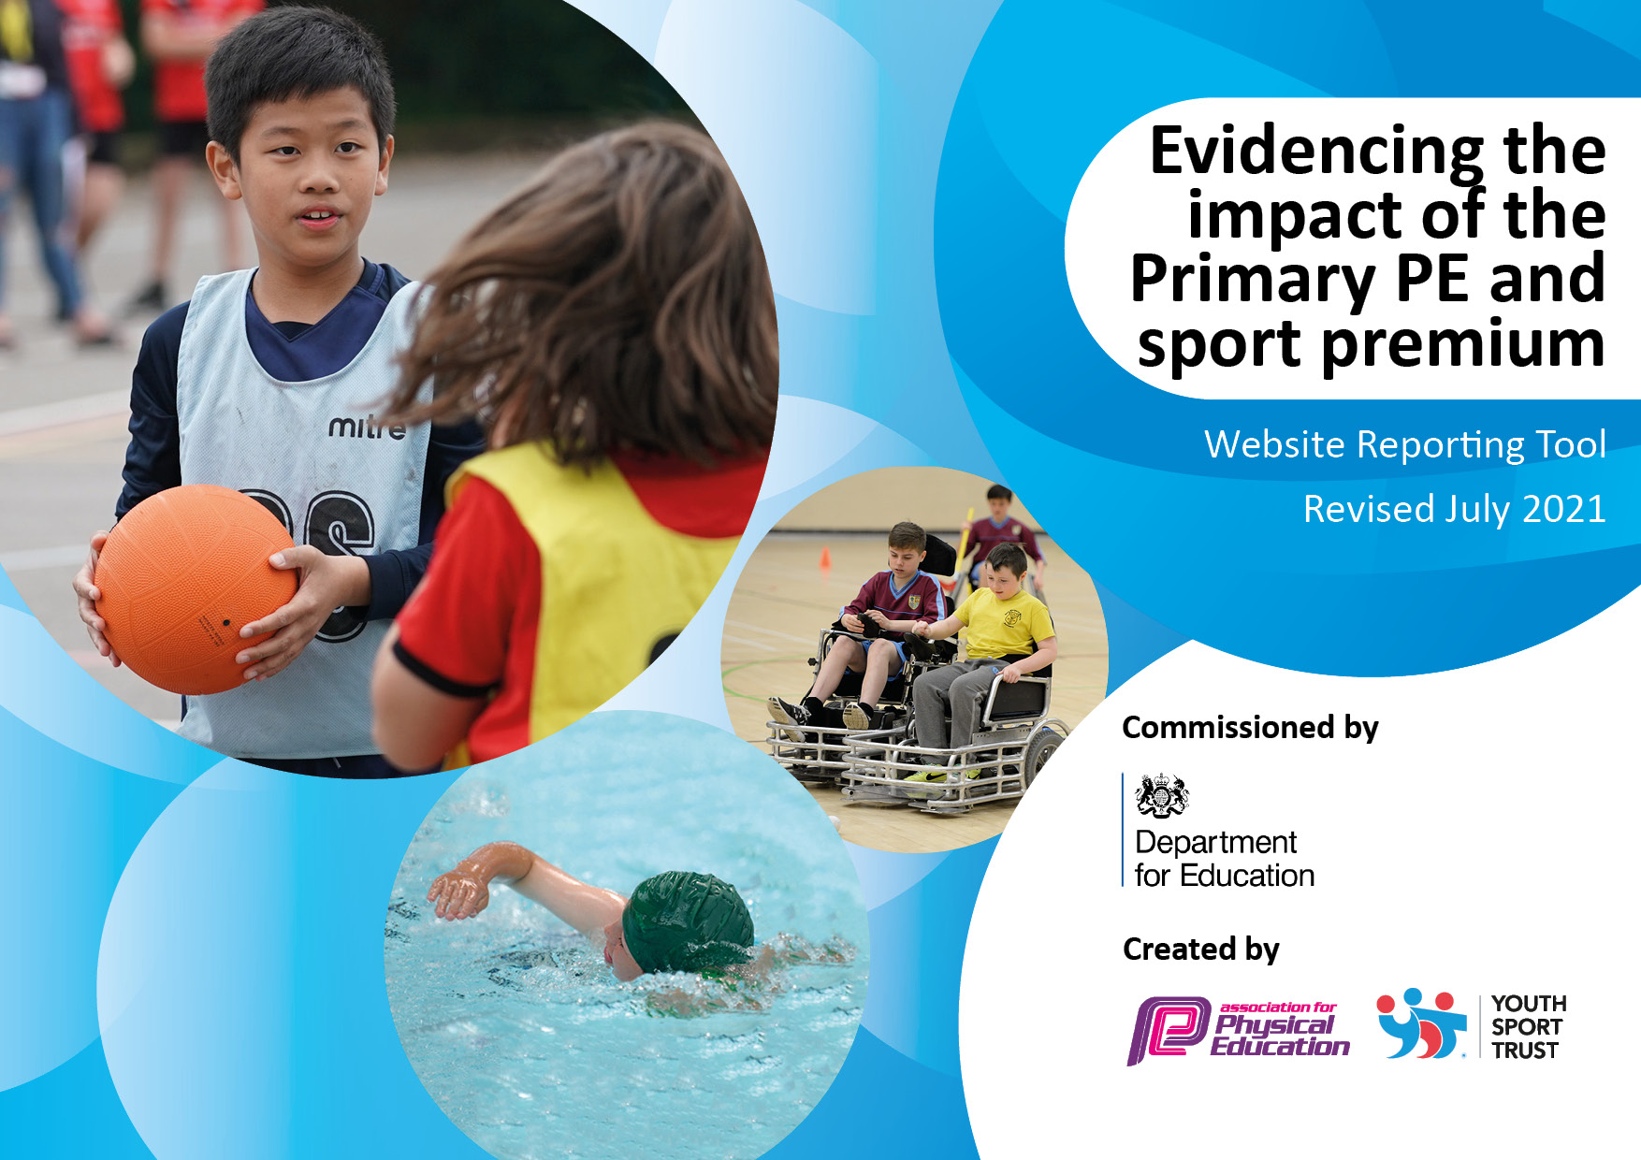

**Great Heath Academy**

**Sport Premium**

**2023 - 2024**

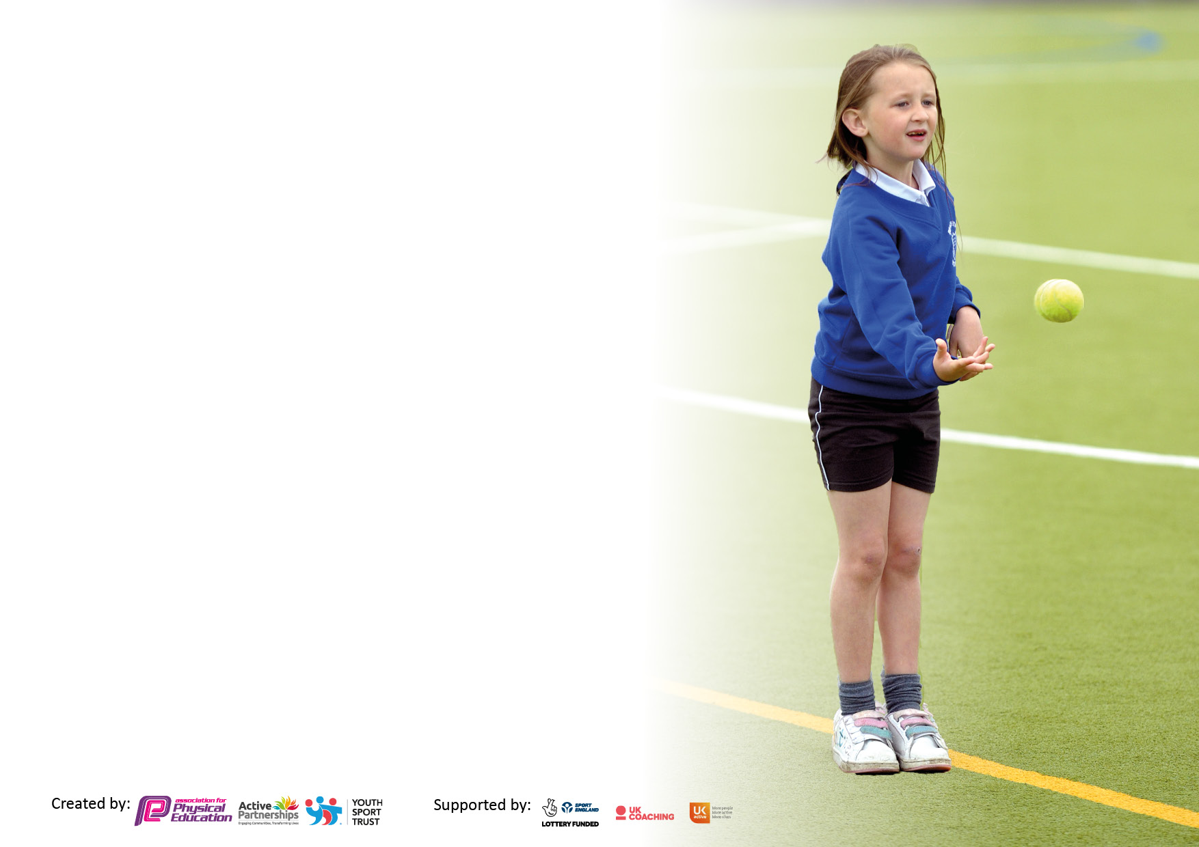

It is important that your grant is used effectively and based on school need. The [Education Inspection Framework](https://assets.publishing.service.gov.uk/government/uploads/system/uploads/attachment_data/file/843108/School_inspection_handbook_-_section_5.pdf) makes clear there will be a focus on **‘whether leaders and those responsible for governors all understand their respective roles and perform these in a way that enhances the effectiveness of the school’**.

Under the [Quality of Education](https://assets.publishing.service.gov.uk/government/uploads/system/uploads/attachment_data/file/843108/School_inspection_handbook_-_section_5.pdf) Ofsted inspectors consider:

**Intent** - Curriculum design, coverage and appropriateness

**Implementation** - Curriculum delivery, Teaching (pedagogy) and Assessment

**Impact** - Attainment and progress

To assist schools with common transferable language this template has been developed to utilise the same three headings which should make your plans easily transferable between working documents.

Schools must use the funding to make **additional and sustainable** improvements to the quality of Physical Education, School Sport and Physical Activity (PESSPA) they offer. This means that you should use the Primary PE and sport premium to:

* Develop or add to the PESSPA activities that your school already offer
* Build capacity and capability within the school to ensure that improvements made now will benefit pupils joining the school in future years
* The Primary PE and sport premium should not be used to fund capital spend projects; the school’s budget should fund these.

Please visit [gov.uk](https://www.gov.uk/guidance/pe-and-sport-premium-for-primary-schools) for the revised DfE guidance including the 5 key indicators across which schools should

Demonstrate an improvement. This document will help you to Review your provision and to report your spend. DfE encourages schools to use this template as an effective way of meeting the reporting requirements of the Primary PE and sport premium.

We recommend you start by reflecting on the impact of current provision and reviewing the previous spend.

Schools are required to [publish details](https://www.gov.uk/guidance/what-maintained-schools-must-publish-online#pe-and-sport-premium-for-primary-schools) of how they spend this funding, as well as on the impact it has on pupils’ PE and sport participation and attainment. **All funding must be spent by 31st July 2023.**

We recommend regularly updating the table and publishing it on your website throughout the year. This evidences your ongoing self-evaluation of how you are using the funding to secure maximum, sustainable impact. Final copy must be posted on your website by the end of the academic year and no later than the 31st July 2021. To see an example of how to complete the table please click [HERE](http://www.afpe.org.uk/physical-education/wp-content/uploads/afPE-Example-Template-Indicator-2018-Final.pdf).



**Details with regard to funding**

Please complete the table below.

|  |  |
| --- | --- |
| Total amount carried over from 2022/23 | £0 |
| Total amount allocated for 2022/23 | £ |
| How much (if any) do you intend to carry over from this total fund into 2023/24? | £0 |
| Total amount allocated for 2023/24 | £21,000 |
| Total amount of funding for 2023/24. To be spent and reported on by 31st July 2024. | £21,000 |

**Swimming Data**

Please report on your Swimming Data below.

|  |  |
| --- | --- |
| Meeting national curriculum requirements for swimming and water safety.  N.B. Complete this section to your best ability. For example you might have practised safe self-rescue techniques on dry land which you can then transfer to the pool when school swimming restarts.  **Due to exceptional circumstances priority should be given to ensuring that pupils can perform safe self rescue even if they do not fully meet the first two requirements of the NC programme of study** |  |
| What percentage of your current Year 6 cohort swim competently, confidently and proficiently over a distance of at least 25 metres? | 60% |
| What percentage of your current Year 6 cohort use a range of strokes effectively [for example, front crawl, backstroke and breaststroke]?  Please see note above | 60% |
| **What percentage of your current Year 6 cohort perform safe self-rescue in different water-based situations?** | 55% |
| Schools can choose to use the Primary PE and sport premium to provide additional provision for swimming but this must be for activity **over and above** the national curriculum requirements. Have you used it in this way? | No |

**Action Plan and Budget Tracking**

Capture your intended annual spend against the 5 key indicators. Clarify the success criteria and evidence of impact that you intend to measure to evaluate for pupils today and for the future.

|  |  |  |  |  |
| --- | --- | --- | --- | --- |
| **Academic Year:** 2023/24 | **Total fund allocated: 20,250** | **Date Updated: 31/07/2024** | |  |
| **Key indicator 1:** The engagement of all pupils in regular physical activity – Chief Medical Officers guidelines recommend that primary school pupils undertake at least 30 minutes of physical activity a day in school | | | | **Percentage of total allocation: 37%** |
| **Intent** | **Implementation** | | **Impact** |  |
| **Your school focus should be clear what you want the pupils to know and be able to do and about**  **what they need to learn and to**  **consolidate through practice:** | **Make sure your actions to achieve are linked to your intentions:** | **Funding allocated:** | **Evidence of impact: what do pupils now know and what can they now do? What has changed?:** | **Sustainability and suggested next steps:** |
| **Pupils access to high quality PE lessons per week. All children receive 2 hours a week of PE**  **This will ensure that all staff can deliver better quality lessons**  **Continue to Improve Early year balance and gross motor skills**  **After school clubs to be set up to help increase the number of children taking part in physical activity.**  **Purchase new equipment to support**  **the teaching of PE and ensure a range of different sports are introduced.** | **Two hours of PE planned per week for each class**  **Ensure updated curriculum is monitored for effectiveness.**  **This will help to improve teachers knowledge and therefore the quality of teaching.**  **https://www.getset4pe.co.uk/**  **Balanceability training provided by Forest heath school sports partnership**  **After school clubs set to suit seasons and competitions. Letters sent out to parents**  **Old equipment will be**  **checked regularly and replaced**  **where necessary. New equipment will be used to support both PE lessons, lunchtimes and after school clubs.** | **Purchase Get set 4 PE £550**  **Balanceability coaching**  **£1500**  **Support for After school clubs**  **£500**  **New equipment purchased £4500** | **Purchased Get Set 4 PE which has been followed by Teachers. This is ensuring progression throughout the school. This has also helped improve the knowledge and confidence of teachers, teaching**  **PE.**  **Monitoring of PE lessons showed a range of sports are taught and skills covered. Staff are using the scheme accurately and this is supporting their knowledge and skills.**  **Children report that they enjoy PE lessons and when questioned are able to demonstrate skills or understanding of terms. These skills are also transferred into competitions.**  **Reception children improved balance, confidence and gross motor skills. Early Learning goals shows an increase in gross motor skills and the number of pupils meeting the standard.**  **We have had different after school clubs running across the year offering a variety of different sports.**  **New equipment has been**  **Purchased eg new netballs, rugby balls and footballs, to ensure lessons are taught to the best possible standard.**  **Equipment has also been purchased for lunchtime to enable all children to be active and engaged** | **Continue to monitor PE lessons to check quality of PE and provide support to class teachers in teaching the lessons**  **Sports leaders need to be**  **developed further to enhance physical activity at lunch times.**  **Continue to ensure that there is sufficient PE resources and equipment for lessons.** |
| **Key indicator 2:** The profile of PESSPA being raised across the school as a tool for whole school improvement | | | | **Percentage of total allocation: 20%** |
| **Intent** | **Implementation** | | **Impact** |  |
| **Your school focus should be clear what you want the pupils to know and be able to do and about**  **what they need to learn and to**  **consolidate through practice:** | **Make sure your actions are linked to your intentions:** | **Funding allocated:** | **Evidence of impact: what do pupils now know and what can they now do? What has changed?** | **Sustainability and suggested next steps:** |
| **Children participate in inter and intra sporting competition during the year.**  **Celebrate achievements of sporting teams with the rest of the school**  **Celebrate achievements of participation in outside sport with the rest of the school.** | **Children attend sporting clubs with focus on improving skills in preparation for team games.**  **After competing in competitions, either in school or with other schools, children's participation and achievements will be celebrated in assemblies and on the weekly newsletters.** | **£2000 for equipment further to new resources**  **£1550 Fee for being member of FHSP** | **Numerous sports clubs have been conducted this year eg Football, cricket, ball skills, rugby. These have been well attended and in some cases over subscribed. Children have benefitted from extra coaching and also improving their skills.**  **The school has competed in numerous sporting events in and out of school eg football, athletics, cross-country, swimming, orienteering. They have benefitted from coaching and also participating in an event outside the school and also boosted their morale, pride and so fostering a positive outlook on school. This has been shared by the staff and parents.**  **Children who have had sporting**  **achievements have been**  **celebrated during our weekly**  **praise assembly and also mentioned in newsletters, facebook and school twitter.** | **For 23/24 continue to regularly check**  **equipment and replace where needed.**  **Audits of equipment carried out termly** |

|  |  |  |  |  |
| --- | --- | --- | --- | --- |
| **Key indicator 3:** Increased confidence, knowledge and skills of all staff in teaching PE and sport | | | | **Percentage of total allocation:** |
| **20%** |
| **Intent** | **Implementation** | | **Impact** |  |
| **Your school focus should be clear** | **Make sure your actions to** | **Funding** | **Evidence of impact: what do** | **Sustainability and suggested** |
| **what you want the pupils to know** | **achieve are linked to your** | **allocated:** | **pupils now know and what** | **next steps:** |
| **and be able to do and about** | **intentions:** |  | **can they now do? What has** |  |
| **what they need to learn and to** |  |  | **changed?:** |  |
| **consolidate through practice:** |  |  |  |  |
| **PE lead to attend any CPD**  **opportunities and feedback to staff accordingly**  **Provide support and training to staff via external coaches in key identified sports** | **PE lead will be able to support**  **teachers. Release time given for PE lead to support teachers**  **Through the Forest Heath sports partnership coaches in Dance, Gym and netball booked to coach the children and also train class teachers** | **Training for sports leader provided at PE meetings - £500 for attending leaders course**  **Dance coach £1000**  **Gym coach £1060**  **Netball Coach £1000** | **PE Leaders knowledge of PE and certain sports enhanced and used to make clear observation of teaching PE across the school. Coaching was then provided to staff that were identified.**  **All teachers taught lessons alongside the external coaches and all have stated that they understand the game more and have great skills to teach these games. They state that they have more confidence in teaching PE lessons. This has a positive impact on the children in the lessons.**  **Children also have developed greater skills.**  **Children in Year 5 achieved 3rd place in the netball tournament, demonstrating application of skills that were taught** | **Continue to work with FHSP to provide further CPD for other members of staff.**  **Continue to subscribe to Get**  **Set 4 PE, for teachers to use to**  **ensure progress of knowledge**  **and skills.**  **As teachers have moved into different year groups this year coaches will be Booked for the same sports.** |
| **Key indicator 4:** Broader experience of a range of sports and activities offered to all pupils | | | | **Percentage of total allocation:** |
| **15%** |
| **Intent** | **Implementation** | | **Impact** |  |
| **Your school focus should be clear** | **Make sure your actions to** | **Funding** | **Evidence of impact: what do** | **Sustainability and suggested** |
| **what you want the pupils to know** | **achieve are linked to your** | **allocated:** | **pupils now know and what** | **next steps:** |
| **and be able to do and about** | **intentions:** |  | **can they now do? What has** |  |
| **what they need to learn and to** |  |  | **changed?:** |  |
| **consolidate through practice:** |  |  |  |  |
| **Have a wider range of sports within the PE curriculum and long-term plan**  **Clubs offered with a wider variety of sporting opportunities to encourage the children to participate in wider sporting opportunities.**  **Children in Year 5 learn First aid** | **Using the scheme of work from Getset4PE long term plan for each year group from Nursery to Year 6 is mapped out to ensure a wide range of sports that include fitness, invasion and teams games, dance, gym, orienteering, swimming, yoga**  **Also sports day at the end of the summer term provides a range of activities that enables all the children to take part.**  **Participate in as many school competitions as possible.**  **Keeping a record of these and the children that are taking part.**  **Children are able to know the basics of first aid. Training is provided by the Mini Medic group that are sourced from the Forest Heath Sports partnership.** | **Cost of buying the scheme of work (Already accounted for in part 1)**  **Clubs run by Teacher are free**  **Other funds £500**  **All Year 5 children taking part. 3 classes**  **£900** | **Long term plan mapped out and available to all staff on the internet via the Getset 4PE website.**  **Monitoring of lessons showed that all teachers followed the long-term plan providing the children a broad a balanced PE curriculum.**  **Lesson plans for each lesson within the individual sport is also provided on the website with resources needed and skills to teach.**  **A wide range of clubs were provided before school, after school and some during lunch in Years 3-6**  **Number of children attending these clubs ranges from 20-30.**  **All the children learnt new life saving skills and were confident to talk about it and demonstrate on the models.** | **23/24**  **Review long-term plan and rewrite for this year taking views of teachers and children.**  **23/24**  **Continue to arrange and provide a wide range of sports at lunch times, before school and after school. Review the skills covered in these clubs.**  **Continue to provide this training** |

|  |  |  |  |  |
| --- | --- | --- | --- | --- |
| **Key indicator 5:** Increased participation in competitive sport | | | | **Percentage of total allocation: 8%** |
| **Intent** | **Implementation** | | **Impact** |  |
| **Your school focus should be clear**  **what you want the pupils to know**  **and be able to do and about**  **what they need to learn and to**  **consolidate through practice:** | **Make sure your actions to** | **Funding** | **Evidence of impact: what do** | **Sustainability and suggested** |
| **In school competitions, between**  **classes in each year group, to be held throughout the year.**  **Sports day to be held in each key**  **stage phase to ensure all pupils take**  **part in competition**  **Children will be given the opportunity to take part in competitions against other schools as part of the FHSP** | **School intra cross country competition to be held in the school.**  **Dance and skipping virtual competitions in school and also against other schools**  **PE lead entered the school for many sporting competitions each term organised by FHSP. Children were then selected based on participation in clubs and also trail.** | **£0**  **£1000 transport cost for hiring Minibus** | **Children from Years 1-6 took part in a virtual cross-country as part of the FHSP.**  **Children from Years R to Year 6 all took part in a virtual dance activity which was held via Teams and was led by two dance teacher. Other schools from the sports partnership were also on the activity. This was very successful as all children had fun so boosted their moral and pride and their also learn new skills and were active**  **Children took part in a virtual skipping competition.**  **Pupils increased their participation in sports that were not part of the planned PE lessons and also competed against children from many other schools. This was inclusive as all children took part and were scored.**  **Many children have had the opportunity**  **to take part in external football, orienteering, netball, swimming and cricket events.**  **The children experienced playing sport against other schools and this helped them build resilience, as well as team work.**  **There were many successes this year in team sports against other schools:**  **Year 5/6 mixed football 3rd place**  **Girls football team 4th Place**  **Year 5 Netball mixed 3rd place**  **Orienteering Years 5/6 1st place**  **Cricket mixed 3rd Place**  **Cricket Girls 5th Place** | **Continue to plan for intra and inter sporting events and enter children into the competitions.**  **Continue to arrange for the children to be selected for sporting events in and outside of school.**  **Develop ways to in ensure all children are able to participate.** |

|  |  |
| --- | --- |
| Signed off by | |
| Head Teacher: | **Naomi Brown** |
| Date: | **31/07/2024** |
| Subject Leader: | **David Hicks** |
| Date: | **31/07/2024** |
| Governor: |  |
| Date: |  |