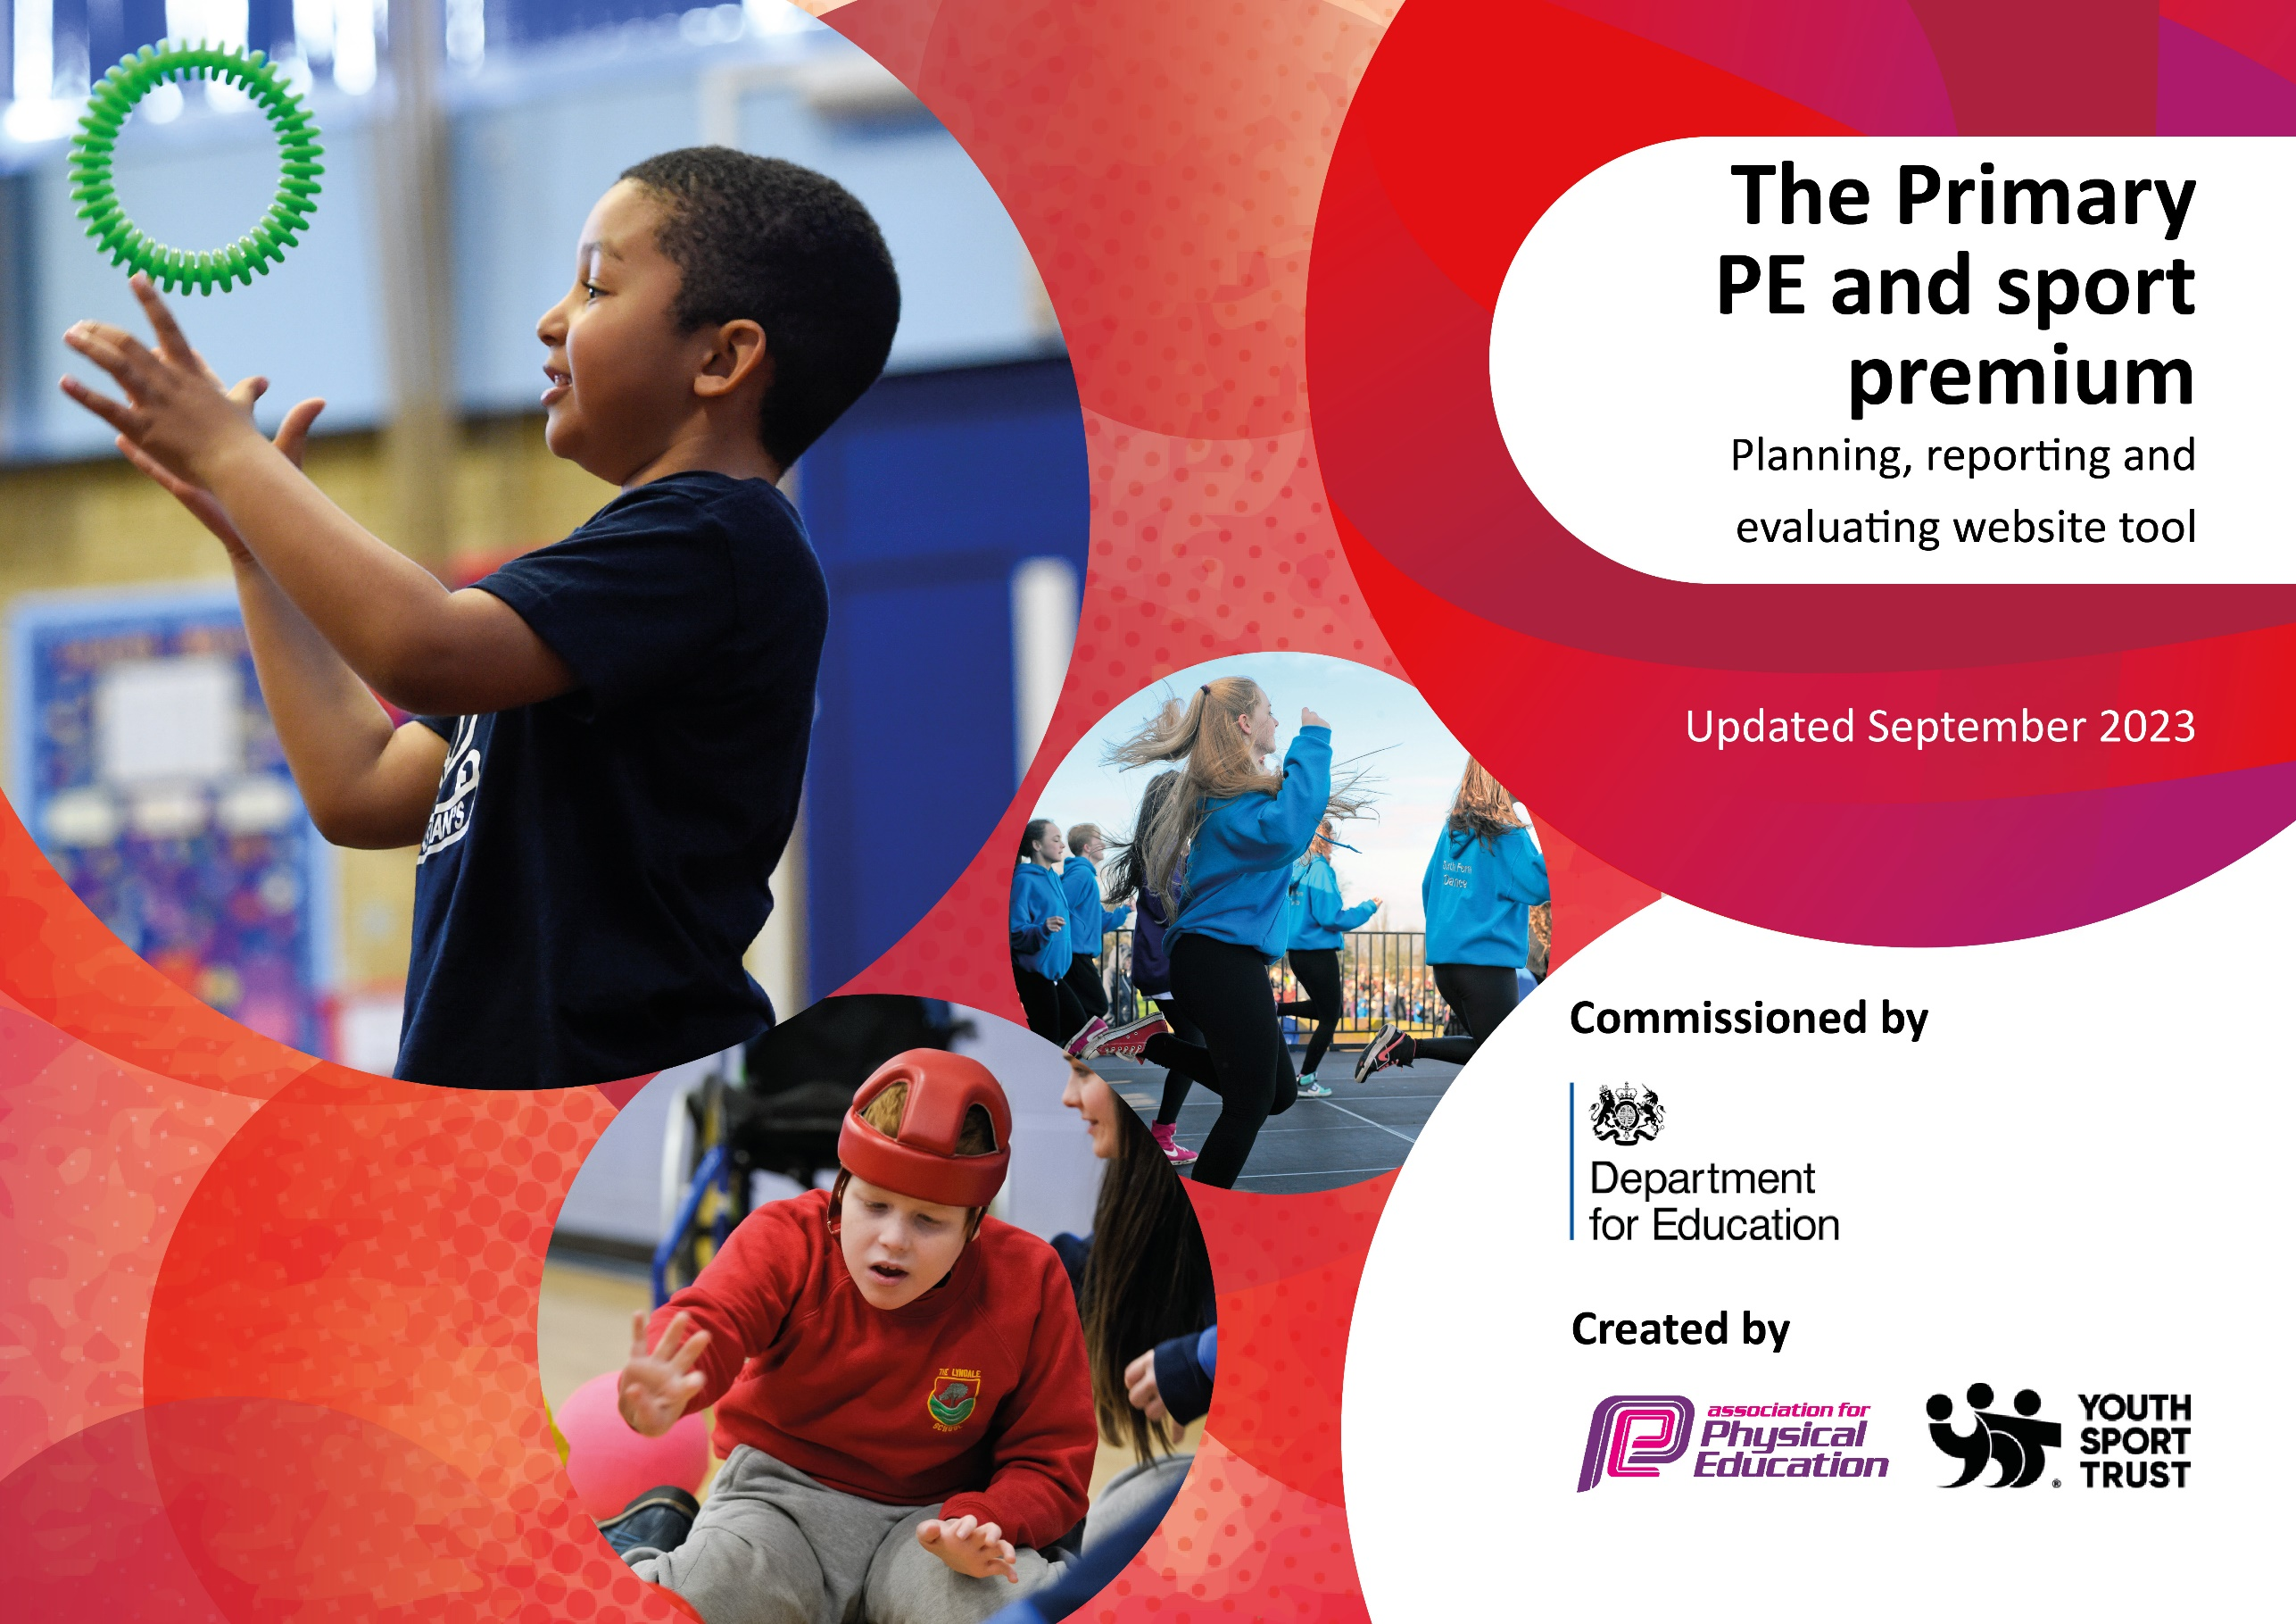

Great Heath Academy
Sport Premium
2024 - 2025

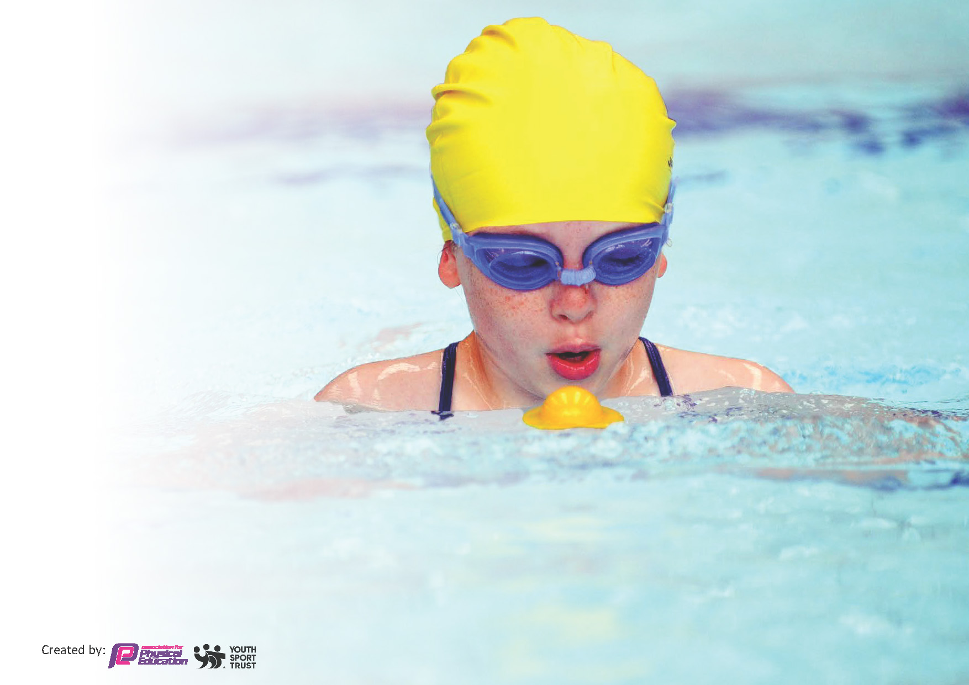
This template can be used for multiple purposes:
by:
- It enables schools to effectively plan their use of the Primary PE and sport premium
- It helps schools to meet the requirements (as set out in guidance) to publish information on their Primary PE and sport premium
- It will be an effective document to support Ofsted inspections enabling schools to evidence progress in Physical Education (PE) and evidence swimming attainment, which forms part of the PE National Curriculum. We would recommend schools consider
the Intent, Implementation and Impact of any spend, as examined within the Education Inspection Framework.

It is important that your grant is used effectively and based on school need.

Schools must use the funding to make additional and sustainable
improvements to the quality of the PE, School Sport and Physical Activity (PESSPA)
they offer. This means that you should use the Primary PE and sport premium to:

- Build capacity and capability within the school to ensure that improvements made now will benefit pupils joining the school in future years
- Develop or add to the PESSPA activities that your school already offers.

The Primary PE and sport premium should not be used to fund capital spend projects; the school’s core budget should fund these. Further detail on capital expenditure can be found in the updated Primary PE and sport premium guidance.

The Primary PE and sport premium guidance, outlines 5 key priorities that funding should be used towards. It is not

necessary that spending has to meet all the key priorities, you should select the priorities that you aim to use any funding towards.

Although completing this template is not a requirement for schools, schools are required to publish details of how they spend this funding. Schools must also outline what the impact this funding has had on pupils’ PE and sport participation and attainment and how any spending will be sustainable in the future. All funding must be spent by 31st July 2024.

The Department for Education has worked closely with the Association for Physical Education (afPE) and the Youth Sport Trust (YST) to develop this template and encourages schools to use it. This template is an effective way of meeting the reporting requirements of the Primary PE and sport premium.
Review of last year’s spend and key achievements (2023/2024)

We recommend you start by reflecting on the impact of current provision and reviewing your previous spend.

Activity/Action | Impact | Comments
Develop the teaching of PE by enhancing the skills of  class teachers by using targeted coaching and  training  Monitor PE lessons (Conduct Deep dive in PE) to  ensure that PE lessons follow the scheme of work  and skills are taught at a high level  Ensure that PE resources and equipment is kept up to  date. Check sporting equipment for sustainability and  repair  Run inter school sport competitions for all and continue to develop different intra sports events  Provide opportunities for ‘Personal Challenge’ within PE lessons and competitions | High impact in some area/sports as coaches were  employed from the Forest Heath Sports  partnership to provide CPD. These were targeted sports and reflected the teachers lack of skills in these sports. The impact was seen in their increased confidence in staff and also participation in internal and external competitions.  Lessons were observed in all Year groups and with all teachers by PE leader and also members of the SLT. This showed that all lessons were taught following the scheme of work that has been set up. Staff all showed that they were well prepared for the lesson.  The PE resources were audited and displayed better. This enabled staff to collect them and used them. More equipment was purchased to provide some sports better and more resources this had the impact of enabling more children to access the curriculum.  The impact is low in running inter school  Competitions. Cross country was set up and the  whole school ran this in year groups. Also, sports  day provide competition within school as the  children were assigned different coloured teams.  A high impact in the intra sports event. The school is part of the Forest Heath sports partnerships which organize many sporting events. The school entered teams in many of these and were successful in many, for example the U12 boys came second in the football competition. The Year 5/6 team won the orienteering competition. The 3/4 team came third in the indoor athletic competitions.  Personal challenge were set up in each class and a specific sport or activity was conducted each team eg cross-country in the Autumn term and skipping in the summer. | It also needs to be noted that some sports coaches were difficult to find and also unavailable. These will be targeted in the next academic year.  It was noted that in some lessons there needs to be more participation from the children in the lessons and staff needed to adapt the lesson more for some children to support their learning.  We will continue to audit and ensure that equipment is looked after and maintained.  Intention is to continue to entry the intra sports event.  Continue to develop different intra sports events

Key priorities and Planning

Total amount of funding for 2024/25. To be spent and reported on by 31st July 2025. | £19,800

Action – what are you planning to do | Who does this action impact? | Key indicator to meet | Impacts and how sustainability will be achieved? | Cost linked to the action
Introduce lunchtime sport sessions/activities for pupils  This is a new provision called OPAL. There will be new playground zones will support with this to increase regular engagement of all pupils in sport and physical activity | Lunchtime supervisors  teaching staff  Play Co-coordinators - as they need to lead the activity  pupils – as they will take part. | Key indicator 2 -The engagement of all pupils in regular physical activity – the Chief Medical Officer guidelines recommend that all children and young people aged 5 to 18 engage in at least 60 minutes of physical activity per day, of which 30 minutes should be in school.  Key indicator 4: Broader experience of a range of sports and activities offered to all pupils. | More pupils meeting their daily physical activity goal, more pupils encouraged to take part in PE and Sport Activities. | £3000 costs for additional Play Coordinators to support lunchtime sessions.  £1000 to purchase extra resources
Continue to Improve Early year balance and gross motor skills | Children in Reception | Key Indicator 1: Increased confidence, knowledge, and skills of all staff in teaching PE and sport.  Key indicator 2 -The engagement of all pupils in regular physical activity – the Chief Medical Officer guidelines recommend that all children and young people aged 5 to 18 engage in at least 60 minutes of physical activity per day, of which 30 minutes should be in school. | Reception children improved balance, confidence and gross motor skills. Early Learning goals shows an increase in gross motor skills and the number of pupils meeting the standard | Balanceability coaching from Forest Heath Sports Partnership  £1500

CPD for teachers to increase confidence in teaching PE in key areas  Internal and external PD courses for school staff to improve and share good practice and to develop their own confidence. | Identified teaching staff within the school | Key Indicator 1: Increased confidence, knowledge, and skills of all staff in teaching PE and sport.  Key indicator 5: Increased participation in competitive sport. | Primary teachers more confident to deliver effective PE supporting pupils to undertake extra activities inside and outside of school, and as a result improved % of pupil’s attainment in PE. | £5500 for 6 teachers to undertake CPD via the Forest Heath sports partnership
Pupils access to high quality PE lessons per week. All children receive 2 hours a week of PE | All children within the school | Key Indicator 1: Increased confidence, knowledge, and skills of all staff in teaching PE and sport.  Key indicator 2 -The engagement of all pupils in regular physical activity – the Chief Medical Officer guidelines recommend that all children and young people aged 5 to 18 engage in at least 60 minutes of physical activity per day, of which 30 minutes should be in school. | Monitoring of PE lessons showed a range of sports are taught and skills covered. Children report that they enjoy PE lessons and when questioned are able to demonstrate skills or understanding of terms. These skills are also transferred into competitions. | Purchase of Getset4PE scheme £550
Children participate in inter and intra sporting competition during the year.  Celebrate achievements of sporting teams with the rest of the school Celebrate achievements of participation in outside sport with the rest of the school. | All children in School | Key indicator 5: Increased participation in competitive sport. | Children to have the opportunity to take part in external football, orienteering, netball, swimming and cricket events.  The children experienced playing sport against other schools and helping them to build resilience, as well as team work. The impact will also result in teams performing well in team events.  Children who have had sporting achievements to be celebrated during our weekly praise assembly and also mentioned in newsletters, facebook and school twitter. | £3500 for new equipment  £1550 Fee for being member of FHSP  £750 transport cost for hiring Minibus
Children in Year 5 learn First aid  (This is sourced from the Forest Heath Sports Partnership) | Year 5 Children in School | Key indicator 4: Broader experience of a range of sports and activities offered to all pupils. | All the children will learn a new life saving skills and have the knowledge and confidence to help someone. | All three Year 5 Classes will have a lesson.  £550
Children in Year 4 will learn mental health First aid  (This is sourced from the Forest Heath Sports Partnership) | Year 4 Children in School | Key indicator 4: Broader experience of a range of sports and activities offered to all pupils. | All the children will learn about mental health and have a greater knowledge about mental health how it affects people/young child and how they may help someone. | The two Year 4 Classes will have a lesson.  £450
To provide top up swimming lessons for pupils in Year Six not meeting the required standard. | Year 6 pupils | Key indicator 2 -The engagement of all pupils in regular physical activity – the Chief MedicalOfficer guidelines recommend that all children and young people aged 5 to 18 engage in at least 60 minutes of physical activity per day, of which 30 minutes should be in school to promote physical and mental health and well-being and to help to prevent obesity. | Teaching primary school pupils to swim 25 meters has a positive impact, enhancing their safety, health, social skills, and educational outcomes.  Addressing the challenges to ensure equitable access to swimming instruction can maximise these benefits, contributing to the overall well-being and development of children. | £1000

Key achievements 2024-2025
This template will be completed at the end of the academic year and will showcase the key achievements schools have made with their Primary PE and sport premium spending.

Activity/Action | Impact | Comments

Swimming Data
Meeting National Curriculum requirements for swimming and water safety.
Priority should always be given to ensuring that pupils can perform safe self-rescue even if they do not fully meet the first two requirements of the National Curriculum programme of study

Question | Stats: | Further context  Relative to local challenges
What percentage of your current Year 6 cohort can swim competently, confidently and proficiently over a distance of at least 25 metres?
What percentage of your current Year 6 cohort can use a range of strokes effectively [for example, front crawl, backstroke, and breaststroke]?

What percentage of your current Year 6 cohort are able to perform safe self-rescue in different water-based situations? |  | .
If your schools swimming data is below national expectation, you can choose to use the Primary PE and sport premium to provide additional top-up sessions for those pupils that did not meet National Curriculum
requirements after the completion of core lessons. Have you done this?
Have you provided CPD to improve the knowledge and confidence of staff to be able to teach swimming and water safety?

Signed off by:

Head Teacher: | Emily Mitchinson
Subject Leader or the individual responsible for the Primary PE and sport premium: | David Hicks Assistant Principal/PE Leader
Governor: | Steve Shore
Date: | 31st July 2024

