23rd January 2025.

Dear Parents/Carers,

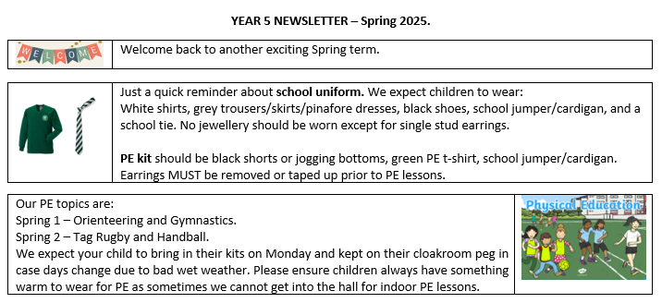

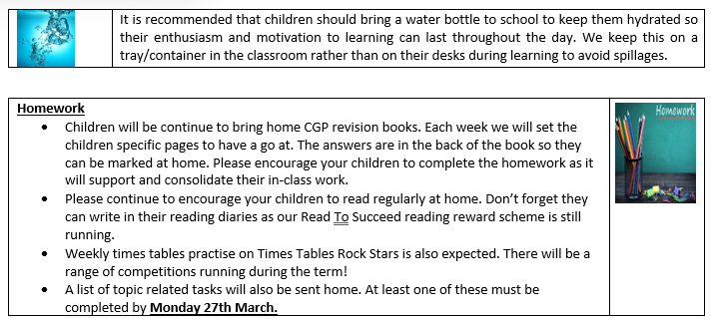

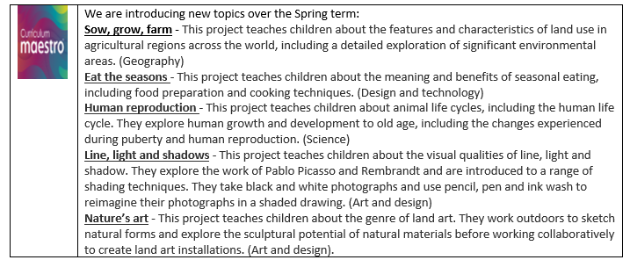

Please contact us on Class Dojo if you have any messages or queries and we will endeavour to reply to messages during school hours. This is also where we will post any updates.

If you are not yet connected to Class Dojo, let your child’s class teacher know and we can sort it out for you.

Kind regards

From The Year 5 team.