
Reception News
Kiwi Class & Mango Class

25th April 2025

Welcome back Reception!
We hope you all had a wonderful break over Easter and enjoyed the lovely weather and some lovely easter eggs!

We want to say a big well done for all of your hard work during the Spring term. We have been so busy learning so many new skills; new sounds in phonics, beginning some early addition and subtraction in maths, some gymnastics and dancing skills in our PE lessons, and much more. We are so proud of you all!

Our Topics

Each week, we base our learning around a book. This half term’s theme is “Creep, Crawl & Wriggle”, which teaches us all about insects and invertebrates that live in our gardens and in the local area.

During this topic we will be looking at the following stories:
Week One - The Very Hungry Caterpillar by Eric Carle
Week Two - Aaargh spider! by Lydia Monks
Week Three – Superworm by Julia Donaldson
Week Four – Monkey Puzzle by Julia Donaldson
Week Five – Little Red and the Very Hungry Lion by Alex T. Smith

Learning about minibeasts is always a great topic and the children are already very excited!

Phonics

During Autumn and Spring terms the children have covered all of the phonics sounds we will be learning in Reception. They have done so well to learn such a variety of sounds, including some very tricky trigraphs and split-digraphs!

This demonstrates how there are lots of different spellings for the sounds we have learnt. They are doing so well to memorise which one to use for each word. We will spend Summer term consolidating this knowledge, before they will go on to learn some more sounds during Year One.

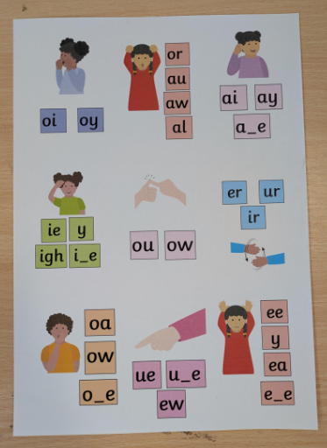

P.E. Kit
Both classes will continue to have PE on a Thursday. With the weather getting much nicer (fingers crossed!) we would love to enjoy our PE lessons outside. Therefore please ensure children have some trainers in their PE kit for wearing outside.

On Thursdays, we ask that long hair is tied back and earrings are removed please. Otherwise we have to tape up the children’s earrings which can be a little bit uncomfortable to remove!

Achievement Assemblies

In the Spring Term we enjoyed taking part in whole-school achievement assemblies on Friday mornings. The children find it very exciting to have their name read out and go to stand at the front of the assembly, in front of the whole school. Lots of our children have now been able to go and collect a reward which is very exciting.

These awards are given out for – Maths Stars (a child who has made an excellent effort in Maths that week), Writing Stars (a child who has tried very hard in their writing activities or phonics lessons), and Red Ted awards. Please don’t forget to record each time your child reads in their reading journal. Each read is stamped with one ‘Red Ted’ stamp. These are counted, and small rewards are given out during assemblies.

OPAL and warmer weather!
You will be aware that we now enjoy playing on the field at lunch time, joining in with the rest of the school. This has been so exciting for everybody and the children love exploring the different resources, and making different friendships. Please ensure that on warmer days, you send in a cap for them to wear at lunch time, and apply sun cream before school.
Reading books and library visits
The children have really been enjoying their weekly library visits. Both classes visit the library on a Friday. The children spend a little while looking through the choice of books and they get to choose one to take home. This book is for pleasure reading and can be shared at home. Library books need to be returned each Friday please, this way, we can issue a new book to be taken home.

Please can you ensure that the children’s individual reading books and reading records are in school every day, this way the children can be read with during the week and their books can be swapped.

Thank you
Many thanks for your continued support,
The Reception Team

Thank you for your continued support ☺
The Reception team
Lunches
Children in Reception, Year 1 and Year 2 are entitled to a free school meal. The menu can be found on the school website. Alongside the main menu item there is always a choice of a jacket potato, cheese or ham sandwiches. Children are asked to make their choice in the morning when they come into school. If you can help your child decide what they would like before coming to school that would be a big help to us! https://greatheathacademy.attrust.org.uk/parents/lunch-menu/

Children do not need to bring a snack to school – there is a fruit snack along with milk and access to their water bottles throughout the day.

