25th April 2025.

Dear Parents/Carers,

**YEAR 5 NEWSLETTER – Summer 2025.**

|  |  |
| --- | --- |
|  | Welcome back to another exciting Summer term. |

|  |  |
| --- | --- |
|  | Just a quick reminder about **school uniform**. We expect children to wear:  White shirts, grey trousers/skirts/pinafore dresses, black shoes, school jumper/cardigan, and a school tie. No jewellery should be worn except for single stud earrings.  **PE kit** should be black shorts or jogging bottoms, green PE t-shirt, school jumper/cardigan. Earrings MUST be removed or taped up prior to PE lessons. |

|  |  |
| --- | --- |
| Our PE Topics are:  Summer 1 – Athletics and Netball.  The children are getting a great opportunity this half term as a Netball coach is coming in to teach 1hr sessions during our P.E slots.  Meteor and Tornado class will be doing this during Summer 1.  Osprey will have the coach sessions during Summer 2.  Summer 2 – Tennis and Cricket.  We expect your child to bring in their kits on Monday and kept on their cloakroom peg in case days change due to bad wet weather. Please ensure children always have something warm to wear for PE as sometimes we cannot get into the hall for indoor PE lessons. |  |

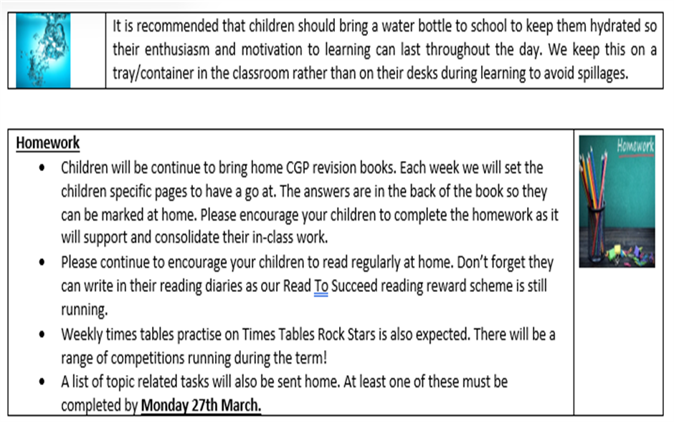

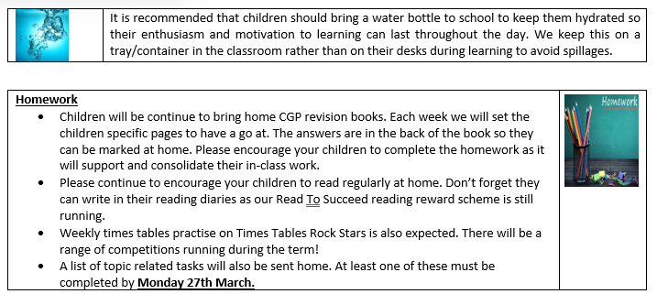

**Monday 14th July**

|  |  |
| --- | --- |
|  | We are introducing new topics over the Summer term:  **Ground-breaking Greeks** - This project teaches children about developments and changes over six periods of ancient Greek history, focusing on the city state of Athens in the Classical age, and exploring the lasting legacy of ancient Greece.  **Architecture** - This project teaches children about how architectural style and technology has developed over time and then use this knowledge to design a building with specific features.  **Properties and changes of materials** - This project teaches children about the wider properties of materials and their uses. They learn about mixtures and how they can be separated using sieving, filtration and evaporation. They study reversible and irreversible changes, and use common indicators to identify irreversible changes.  **Mixed Media** - This project teaches children about paper crafts, papermaking and collage techniques, including paper, fabric, mixed media and photo collage. They use their learning to create a final piece of small-scale, mixed media collage.  **Expression** - This project teaches children about the Expressionist art movement and the 'Father of Expressionism', Edvard Munch. They explore different ways to portray feelings and emotions in art to create an imaginative self-portrait. |

Please contact us on Class Dojo if you have any messages or queries and we will endeavour to reply to messages during school hours. This is also where we will post any updates.

If you are not yet connected to Class Dojo, let your child’s class teacher know and we can sort it out for you.

Kind regards

From The Year 5 team.