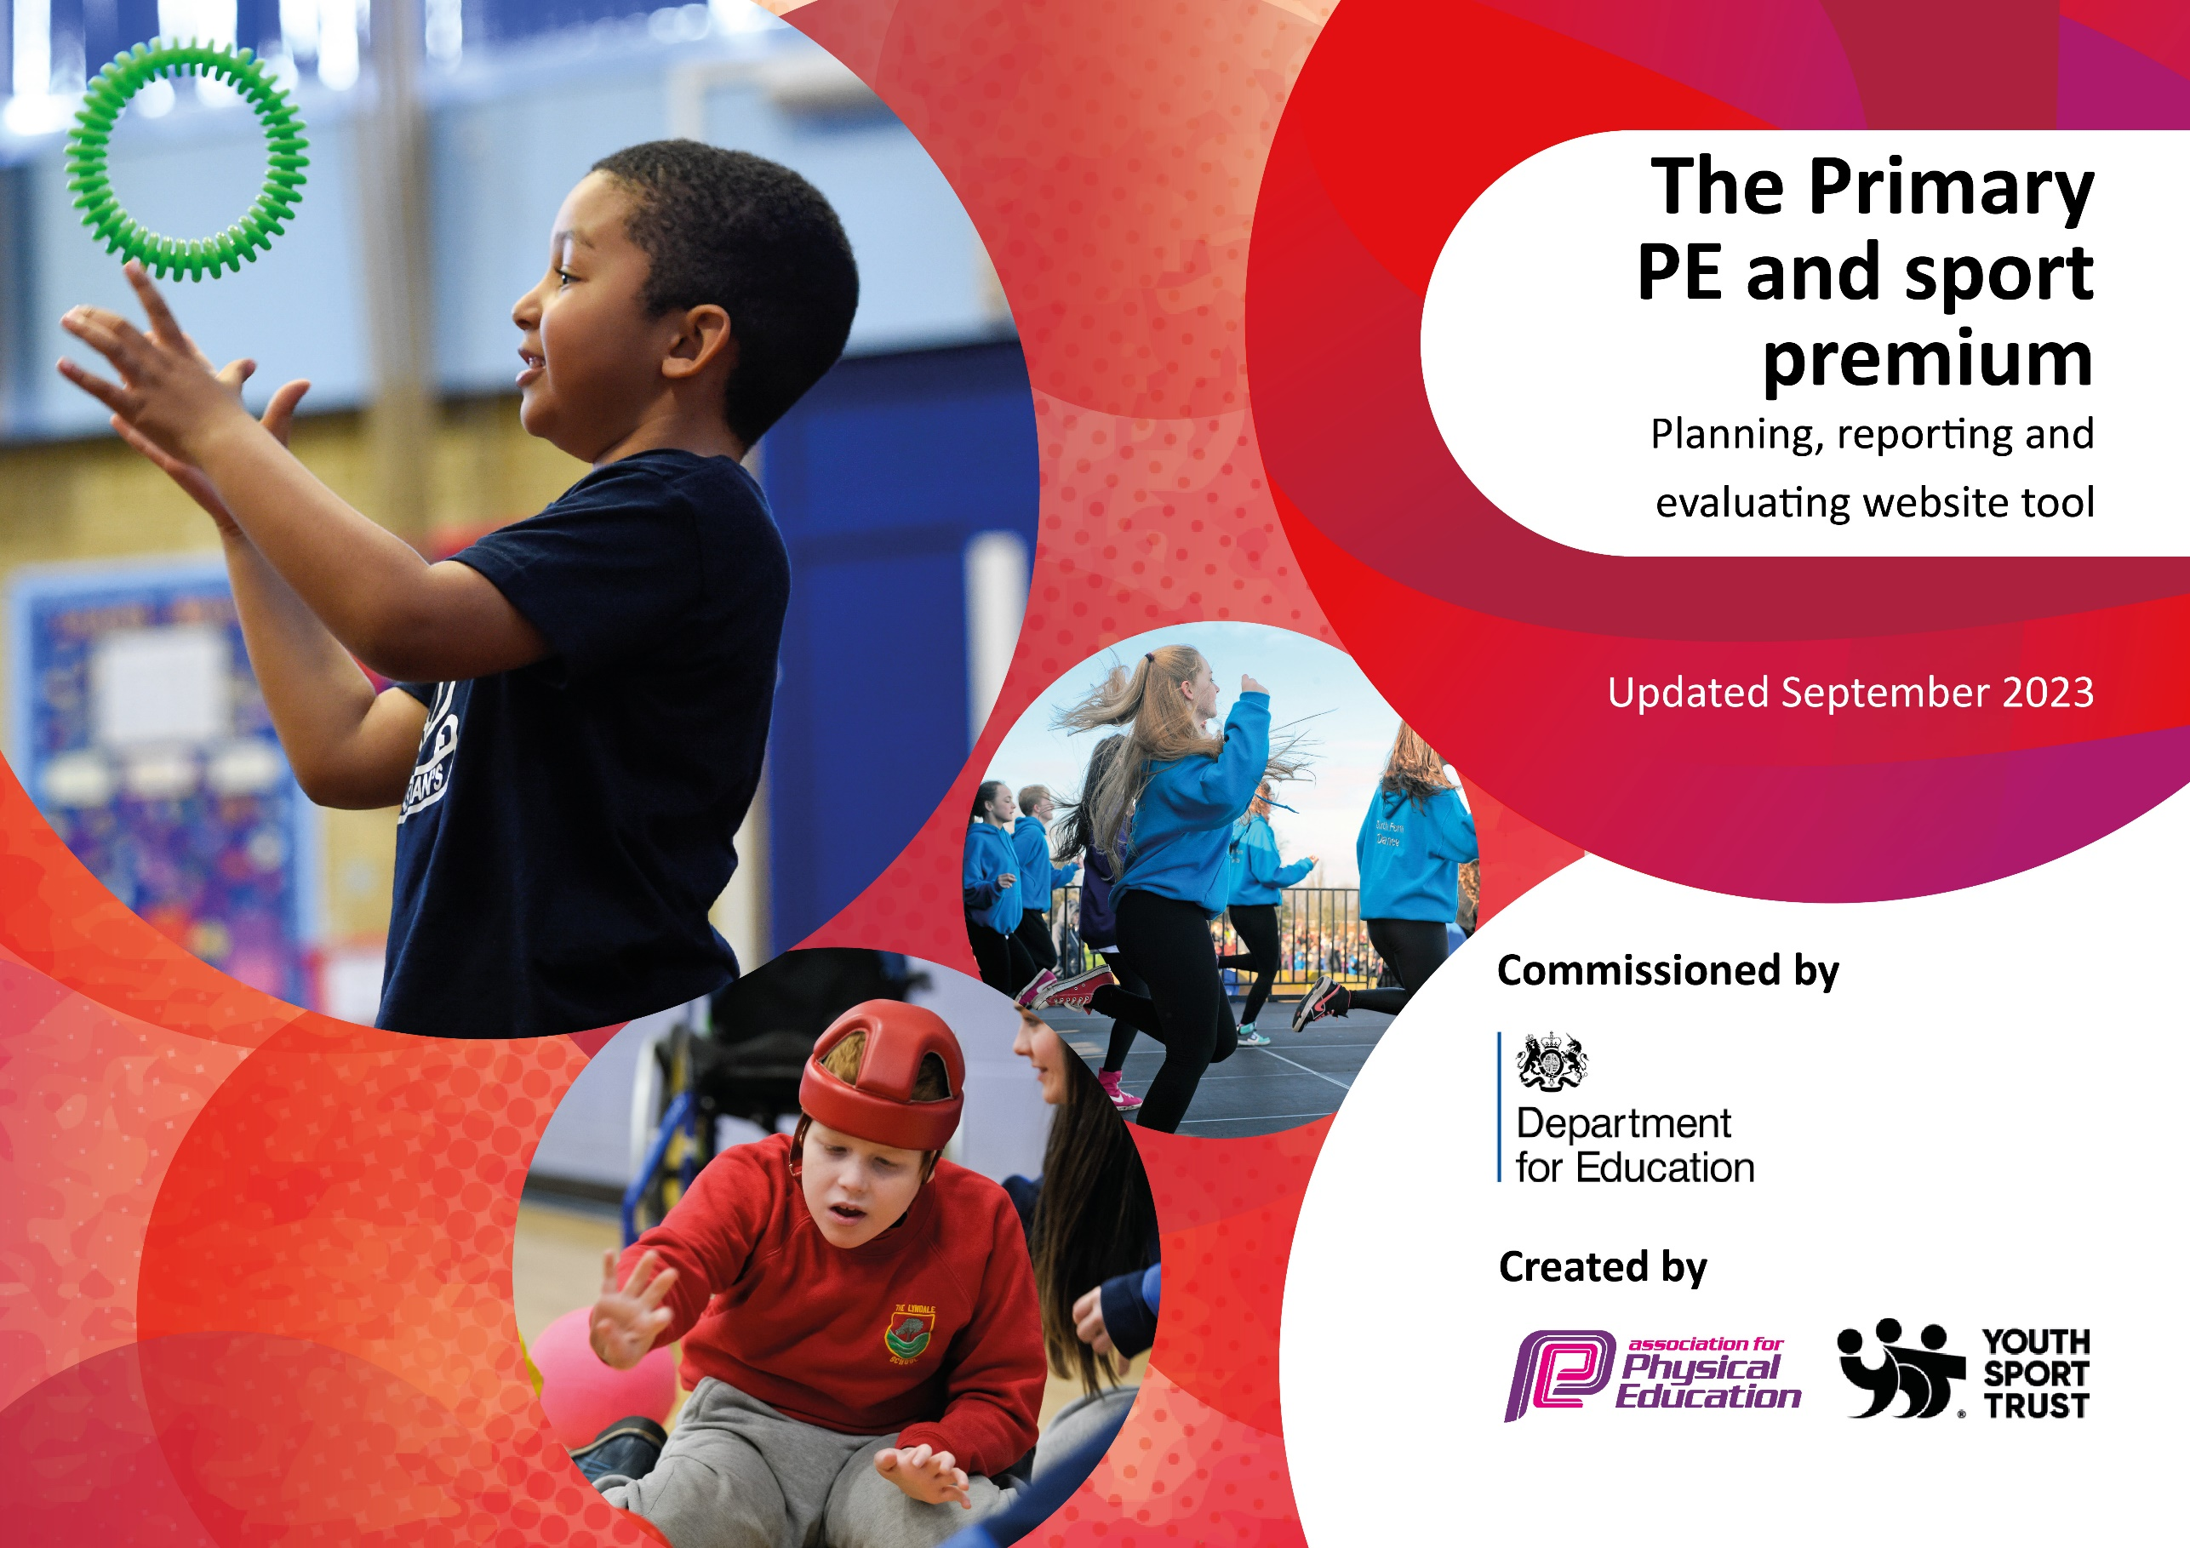

Great Heath Academy
2025-2026

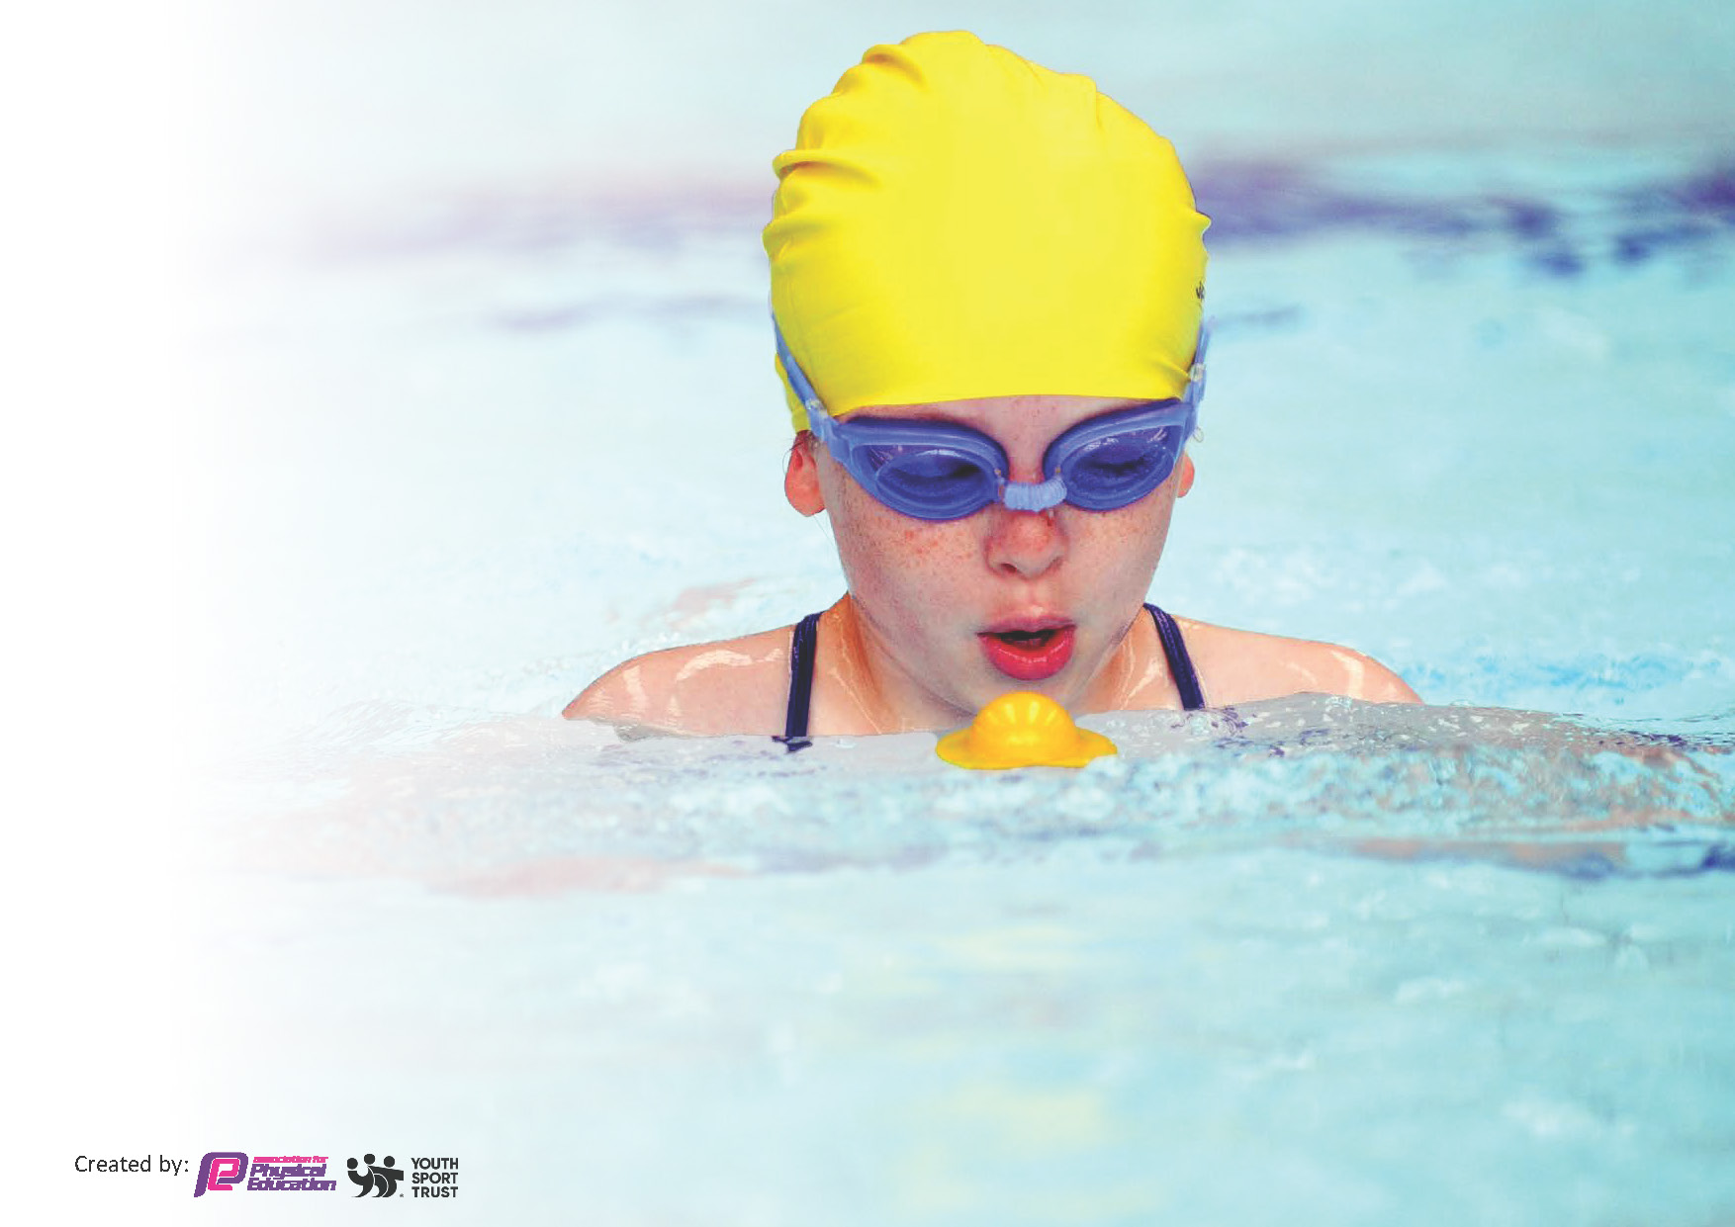
This template can be used for multiple purposes:
by:
- It enables schools to effectively plan their use of the Primary PE and sport premium
- It helps schools to meet the requirements (as set out in guidance) to publish information on their Primary PE and sport premium
- It will be an effective document to support Ofsted inspections enabling schools to evidence progress in Physical Education (PE) and evidence swimming attainment, which forms part of the PE National Curriculum. We would recommend schools consider
the Intent, Implementation and Impact of any spend, as examined within the Education Inspection Framework.

It is important that your grant is used effectively and based on school need.

Schools must use the funding to make additional and sustainable
improvements to the quality of the PE, School Sport and Physical Activity (PESSPA)
they offer. This means that you should use the Primary PE and sport premium to:

- Build capacity and capability within the school to ensure that improvements made now will benefit pupils joining the school in future years
- Develop or add to the PESSPA activities that your school already offers.

The Primary PE and sport premium should not be used to fund capital spend projects; the school’s core budget should fund these. Further detail on capital expenditure can be found in the updated Primary PE and sport premium guidance.

The Primary PE and sport premium guidance, outlines 5 key priorities that funding should be used towards. It is not

necessary that spending has to meet all the key priorities, you should select the priorities that you aim to use any funding towards.

Although completing this template is not a requirement for schools, schools are required to publish details of how they spend this funding. Schools must also outline what the impact this funding has had on pupils’ PE and sport participation and attainment and how any spending will be sustainable in the future. All funding must be spent by 31st July 2026.

The Department for Education has worked closely with the Association for Physical Education (afPE) and the Youth Sport Trust (YST) to develop this template and encourages schools to use it. This template is an effective way of meeting the reporting requirements of the Primary PE and sport premium.
Review of last year’s spend and key achievements (2024/2025)

We recommend you start by reflecting on the impact of current provision and reviewing your previous spend.

Activity/Action | Impact | Comments
Forest Heath Schools Partnership core package  - Balance-ability instructor for Reception classes  - Netball coach for KS2 classes  - CPD package  - Entry to interschools competitions  Subsidy for Y6 residential to allow them to participate in different sports and sports that we cannot access from school, with a focus on ensuring disadvantaged pupils attend  Subscription to Get Set 4 PE scheme to ensure high quality teaching across the school and PE equipment to play different sports  Developing lunchtime play through the OPAL scheme  Widening the range of extra-curricular clubs on offer | This has allowed access to CPD and support for the PE lead and staff, increasing their knowledge and confidence. It has also allowed for access to different coaches to provide high quality teaching to the pupils and CPD for the staff who worked alongside them.  We participated in many competitions between schools including orienteering, cross country, netball, swimming, football and cricket. This widened the number of children who took part in competitive sports and raised the profile of the sports and competitions.  Children widened their experiences and knowledge of different sports  Teaching of PE is consistent across the school. Children learn a variety of sports and develop their skills over time.  Children have greater access to a variety of play activities developing their physical and emotional wellbeing.  This year children across the school have had access to a variety of extra-curricular sports clubs including netball, gymnastics, cricket and football

Key priorities and Planning

Total amount of funding for 2025/26. To be spent and reported on by 31st July 2026. | TBC

Action – what are you planning to do | Who does this action impact? | Key indicator to meet | Impacts and how sustainability will be achieved? | Cost linked to the action
CPD for staff through working with specialist sports coaches | Teaching staff within the school and ultimately pupils | Key Indicator 1: Increased confidence, knowledge, and skills of all staff in teaching PE and sport.  Key indicator 4: Broader experience of a range of sports and activities offered to all pupils. | Increase confidence and knowledge in teaching PE and improving knowledge of specific sports which will support with sustainable impact | £3,800
Provide a wide range of internal activities  - Internal competitions (Sports’ Day)  - school based extra-curricular opportunities (clubs, OPAL)  - top up swimming for Y6  - internal active travel for competitions / residential  - equipment and resources for PE and OPAL  - membership fees for FHSP  - educational platforms – Get Set 4 PE and Yogabugs | All children across the school | Key indicator 2 -The engagement of all pupils in regular physical activity  Key indicator 3: The profile of PE and sport is raised across the school as a tool for whole-school improvement  Key indicator 4: Broader experience of a range of sports and activities offered to all pupils.  Key indicator 5: Increased participation in competitive sport. | All pupils will access daily physical activity through OPAL for 30 mins minimum – this is an ongoing project to create sustainable play opportunities for all children  All pupils will be able to access extra-curricular activities linked to keeping healthy and fit  Greater attainment at the end of Year 6 against the swimming criteria through top up lessons  High quality PE will be taught – the PE bought curriculum supports teachers with developing their confidence and knowledge creating a sustainable improvement in the teaching of PE  Yogabugs will allow all pupils to take part in daily yoga movement and mindfulness activities | Internal competitions - £100  Clubs – £5,500  OPAL – £2,000  Mental health/ first aid training for pupils - £1,200  Top up swimming - £1,000  Active travel - £1,500  Equipment - £3,500  FHSSP membership – £825  Get Set 4 PE – £750  Yogabugs - £1,250
Increase sporting opportunities for targeted pupils through accessing sporting events, clubs and competitions  - girls  - pupils with SEND  - disadvantaged pupils | Specific targeted groups | Key indicator 4: Broader experience of a range of sports and activities offered to all pupils.  Key indicator 5: Increased participation in competitive sport. | Increased participation in sports across all groups  Improved attainment in a variety of sports across the different groups with greater opportunities to practice skills | £250  (clubs payment detailed above)

Key achievements 2025-2026
This template will be completed at the end of the academic year and will showcase the key achievements schools have made with their Primary PE and sport premium spending.

Activity/Action | Impact | Comments

Swimming Data
Meeting National Curriculum requirements for swimming and water safety.
Priority should always be given to ensuring that pupils can perform safe self-rescue even if they do not fully meet the first two requirements of the National Curriculum programme of study

Question | Stats: | Further context  Relative to local challenges
What percentage of your current Year 6 cohort can swim competently, confidently and proficiently over a distance of at least 25 metres?
What percentage of your current Year 6 cohort can use a range of strokes effectively [for example, front crawl, backstroke, and breaststroke]?
What percentage of your current Year 6 cohort are able to perform safe self-rescue in different water-based situations?
If your schools swimming data is below national expectation, you can choose to use the Primary PE and sport premium to provide additional top-up sessions for those pupils that did not meet National Curriculum
requirements after the completion of core lessons. Have you done this?
Have you provided CPD to improve the knowledge and confidence of staff to be able to teach swimming and water safety?

Signed off by:

Head Teacher: | Emily Mitchinson
Subject Leader or the individual responsible for the Primary PE and sport premium: | Michelle Brown -PE Leader
Governor: | TBC
Date: | 31st July 2025

