Welcome to Year Two

Dear Parents / Carers,

We would like to say a huge welcome to all of our families following a well-deserved summer break. We hope the children are feeling rested and ready for the exciting year ahead. We are looking forward to working with you all and we ask you to continue to support your child with their learning at home.

Routine

At the start of the day, children will come into the classroom at **8.40a.m**. Your child needs to be ready with everything they require for the day’s learning including reading book, reading record and a water bottle. The school day finishes at **3.15p.m.**

The children have looked very smart in their uniform this week. Please ensure that all items of uniform are named.

English

Reading: The children will continue to read with an adult during the school week. Each child will also choose a library book from our school library which should be returned the following week. We expect all children to read regularly at home. Please ensure their reading record book is signed by an adult and brought in every day so that they can collect their Red Ted reward points.

Literacy-led English curriculum: At Great Heath Academy, our English curriculum is led by high-quality literacy texts. This term, some of the books we are studying include:

The Giraffe and the Pelly and Me by Roald Dahl

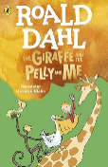

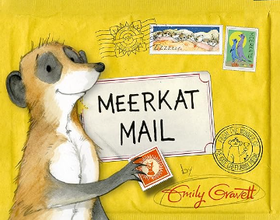

Meerkat Mail by Emily Gravett

Through our English lessons, we will look to develop writing skills such as writing sentences using full stops, capital letters and question marks correctly. We will also be focusing on correct letter formation in preparation for joining handwriting.

Maths

We will continue to use White Rose Maths. The topics studied this term are place value, addition, subtraction and shape. We will be practising the 2, 5 and 10 times tables on a daily basis throughout the year using our rolling numbers songs.

Topics

In the Movers and Shakers project, children will learn about significant people from history including scientists, artists and explorers and be able to place them on a timeline.

P.E.

Our scheduled P.E. lessons are on a **Tuesday** and **Thursday**. Children must bring their named P.E. kit into school on a Monday and these remain in school all week. As some P.E. lessons will be outside the children can wear black shorts or jogging bottoms and trainers, their green school P.E. T-shirt and school jumper.  
**All** jewellery must be removed **at home** on these days.

Homework expectations

* Children to read their school book regularly and discuss it with an adult
* Weekly spelling
* Termly topic activity

If you have any questions at all, please do not hesitate to get in touch. We are looking forward to an exciting year!

Kind regards,

Mrs Morgan-Gray and Miss Saunders