YEAR 5 NEWSLETTER – AUTUMN 2025.

 | Here are the Y5 teaching team with:  Miss Parrington – Meteor  Miss Oakley – Osprey  Teaching Assistants – Mrs Eyres and Mrs Mynott.  PLEASE REMEMBER THAT CLASSROOM DOORS WILL BE OPEN AT 8.40am

We endeavor to offer your child a broad, balanced curriculum that is fun, motivational and is full of incredible information and skills. A punctual start to the school day is essential as each morning we will begin the day with daily activities and Accelerated Reading focusing on your child’s reading skills, extending their language and enhancing their comprehension understanding through a range of genres they will read. The rest of the morning, we will be working on English and Maths. Afternoons will be our topic work, RE, PE, French and interventions that the pupils may require to help them meet their levels. | 

We are very lucky in Year 5 as we work alongside Suffolk County Music enabling the children to learn to play a musical instrument taught by a music teacher. These lessons are compulsory and part of our curriculum.  Here are the details:  Osprey – brass (cornets) on Wednesday mornings  Meteor – guitar on Thursday mornings.  The children will take these instruments home to practice and need to remember to bring them each week for the lesson. Unfortunately, we are unable to change the instruments for individuals but they may get the chance in Y6 with the Play On scheme. | 

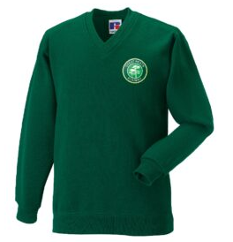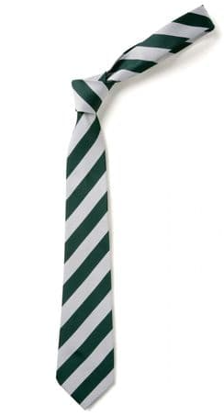 | Just a quick reminder about school uniform. We expect children to wear:  white shirts,  grey trousers/skirts/pinafore dresses,  black shoes,  school jumper/cardigan,  a school tie  (and a green dress in the summer).

This term, we will be practicing Football, Gymnastics, Tag Rugby and Dance.  Children will have to change into their PE kit in school in our changing rooms. They need to be dressed for all weather and temperatures in black shorts (indoor wear), black tracksuit bottoms/black leggings, school t-shirt and a school jumper/cardigan. NO sport logos should be worn.  Please make sure that they have their kits on their pegs Monday – Friday.  No jewellery (especially earrings) or watches (including Fitbits) should be worn and removed before school. | 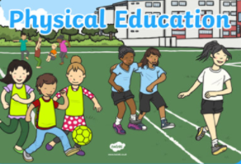

We will continue to send home regular homework tasks for English and Maths (CGP books) – usually giving them a week to complete the task. Any online homework activities can be found on NESSY, Freckle, Purple Mash and Times Table Rock Stars.  Please could you encourage your child to read regularly at home to achieve the Read To Succeed prizes at different amounts of reads. If your child reads at home, can you please sign their reading diaries regularly. They need to continue to keep practicing the times tables accurately and steadily.  We will also be sending home a list of topic homework and would like each child to complete a minimum of one activity per term – date for submission to be shared at the start of term. | 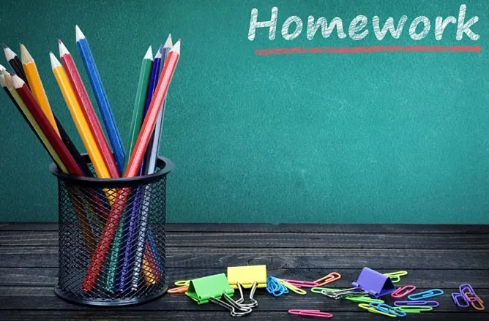

 | We are introducing these topics over the Autumn term:  Dynastic Dynasties - This project teaches children about the history of ancient China, focusing primarily on the Shang Dynasty, and explores the lasting legacy of the first five Chinese dynasties, some of which can still be seen in the world today (History).  Taotie - This project teaches children about the significance and art of the taotie motif, including ancient and contemporary casting methods (Art/Design).  Tints, Tones & Shades - This project teaches children about colour theory by studying the colour wheel and exploring mixing tints, shades and tones. They learn about significant landscape artworks and features of landscapes before using this knowledge to create landscape paintings (Art/Design).  Investigating Our World - This essential skills and knowledge project teaches children about locating map features using a range of methods. They learn about the Prime Meridian, Greenwich Mean Time (GMT), and worldwide time zones and study interconnected climate zones, vegetation belts and biomes. Children learn about human geography and capital cities worldwide before looking at the UK motorway network and settlements. They carry out an enquiry to identify local settlement types (Geography).  Moving Mechanisms - This project teaches children about pneumatic systems. They experiment with pneumatics before designing, making and evaluating a pneumatic machine that performs a useful function (Design Technology).  Forces and mechanisms - This project teaches children about the forces of gravity, air resistance, water resistance and friction, with children exploring their effects. They learn about mechanisms, their uses and how they allow a smaller effort to have a greater effect (Science)

 | We are continuing to use Class Dojos as our school GREAT reward system and hope that your child will achieve enough to earn rewards such as prizes from our treasure chest or some vouchers.

Could you please ensure that your child has a water bottle for school to keep them hydrated so their enthusiasm and motivation for learning can last throughout the day.

Please remember if you have any messages to get in touch with us on your class Dojo page and we will endeavour to reply to your messages and queries during school hours.

From the Year 5 team.

