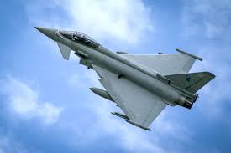

Welcome to Year 6

Dear Parents / Carers,

We would like to say a huge welcome to all of our families following a well-deserved summer break. We hope the children are feeling rested and ready for the exciting year ahead. We are looking forward to working with you all and we ask you to continue to support your child with their learning at home.

**Routine**

At the start of the day, children will be able to come into the classroom at **8.40 a.m**. Your child needs to be ready with everything they require for the day’s learning. Please ensure reading books and reading records are brought in to school **every day**. The school day finishes at **3.15p.m.** If you have not done so already, please let us know, **in writing**, if you would like your child to walk to another part of school to meet a sibling, walk to the gate, or to walk home by themselves. If there are any same-day changes to the agreed collection arrangements for your child, **please ensure you contact the office as we cannot always monitor messages on Class Dojo throughout the school day.**

**English**

Reading: The children will continue to read their Accelerated Reader books in school and take quizzes. Each child will also choose a library book and we expect all children to read regularly at home. Please ensure their reading record book is signed by an adult as they can collect their Read to Succeed reward points.

Literacy-led English curriculum: At Great Heath Academy, our English curriculum is led by high-quality literacy texts. This term we will be studying the following books:

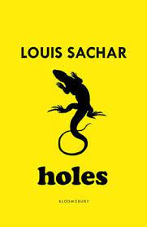Holes by Louis Sachar

Through this book we will look to develop our persuasive writing techniques. We will develop setting and character descriptions by looking at elements of the Wild West. Explanation texts are supported by making connections to Martin Browne’s ‘Lesser Spotted Animals’ book series.

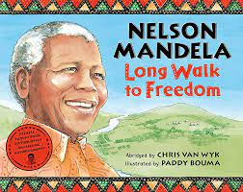Long Walk to Freedom by Chris Van Wyk and Nelson Mandela

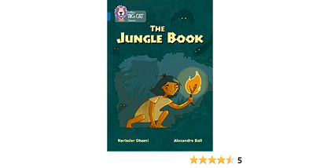This autobiographical book allows children to make connections to our Maafa topic and Black History Month. We will be making comparisons between real-life characters and the structure of non-fiction texts.

The Jungle Book by Rudyard Kipling

We look at this book alongside Kipling’s Just So Stories to explore origin stories. We then create our own to share with younger children in school.

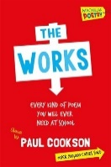The Works poems chosen by Paul Cookson

We will be focussing on conversation poems and preparing poetry to perform.

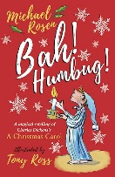

Bah Humbug by Michael Rosen

This is a dual text that incorporates a Charles Dickens’ classic tale. Through this book we will develop formal debating skills, character analysis and writing short ‘flashback’ narratives.

**Maths**

We will continue to use White Rose Maths. The topics studied this term are place value and the four operations (add, subtract, multiply, divide), fractions and converting units.

**Topics**

In the Crime and Punishment project, children will learn about changes in this social aspect of British history. Our learning will be supported by a visit to the Tower of London on the 23rd September (further details to follow shortly).

In the Maafa project, children will learn about Africa today and the ancient kingdoms that thrived on the continent for thousands of years. They will study the origins and structure of the transatlantic slave trade and the consequences of enslavement for enslaved people. They will learn about the causes and consequences of the abolition of slavery in the 19th century. They will also explore the lives of black people who have made significant contributions to Britain and black culture in Britain today.

We will also be looking at Art, Design and Technology, Geography and Science through various companion projects.

**P.E.**

Our P.E. days are scheduled for:

Hurricane and Typhoon – Mondays and Thursdays Spitfire – Tuesdays and Thursdays

We ask that P.E. kits are brought into school on a Monday and these will stay in school until Friday, should there be any changes to our timetable. For outside P.E. lessons children can wear black shorts or jogging bottoms and trainers with a green P.E. T-shirt and jumper. Please ensure all P.E. kits are named. **All jewellery MUST be removed at home on planned PE days.**

**Homework expectations**

* Children to read their school book **daily** and discuss it with an adult, who then writes a comment and signs the yellow reading record.
* Weekly activities from the CGP Books (Reading, Grammar, Spelling, and Maths) as set by the class teacher. Activities to be completed will be shared on Class Dojo each week. Homework will be set on a Thursday each week, and completed homework books should be returned to class by the following Wednesday.

In addition, children will continue to have weekly spelling tests and the words that children have been learning that week in lessons will be sent home on a Friday. It would benefit children to continue to regularly practise spelling words/patterns from the Year 3/4 and Year 5/6 statutory spelling lists. Please let us know if you need a copy of these.

Although not compulsory, we will also set tasks on Freckle, which will support the learning that has been taking place in class. Children can also access TT Rockstars at home. We appreciate your support in encouraging your child to engage with these learning platforms (children can also choose other activities to complete, if they wish.)

Mobile phones

If your child needs to bring a mobile phone to school, these **MUST** be handed in at the office **prior to** registration and collected at the end of the day.

If you have any questions at all, please do not hesitate to get in touch. We are looking forward to an exciting year!

Kind regards,

Mrs. Ashford, Mrs. Brown and Miss Hornsby